eta





**Tutorial TWIST-SPIN board**

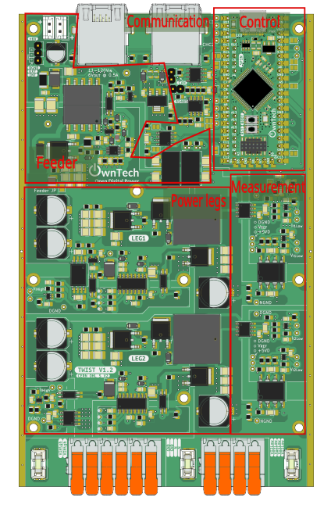

Table of contents

Setting your environment 5

Objective 5

Required Software 5

Your First Build 7

Blinky: Our First Code! 9

Objectives 9

Modifying the Code 9

Expected results 11

Saving Modifications to the Board Code using Git 13

Required Software 13

Objective 13

Using Git 13

Buck Converter with Open-Loop 15

Objective 15

Required Hardware 15

Required Software 15

Create the Project 15

Step-by-Step Implementation 15

Expected Results 20

Measurement Activation 21

Objective 21

Required hardware 21

Required Software 21

Creating the Project 21

Step-by-Step Implementation 22

Expected Results 25

Board Sensors Calibration 26

Required hardware 26

Required Software 26

Objective 26

What is Sensor Calibration? 26

Calibrating V_HIGH and I_HIGH 27

Calibrating V_Low 1, 2 et I_Low 1,2 : 31

Ownplot : View measured data 34

Objective 34

Required hardware 34

Required Software 34

Expected Results 36

Plot with OwnPlot 36

Buck Converter in Closed Loop 41

Required hardware 41

Required Software 41

Step-by-Step Implementation 41

Code explanation 47

Connect hardware and Power up 48

Closed-Loop Buck Converter with Adjustable Voltage Reference 49

Required hardware 49

Required Software 49

Step-by-Step Implementation 49

Code explanation 51

Connect Hardware and Power Up 51

Closed-Loop Boost Converter 53

Required hardware 53

Required Software 53

Step-by-Step Implementation 53

Code explanation 58

Connect Hardware and Power Up 59

Boost Converter in Closed-Loop with Adjustable Voltage Reference 60

Required hardware 60

Required Software 60

Step-by-Step Implementation 60

Code Explanation 62

Power Up and Connect Your TWIST Board 62

Convertisseur Buck : Pompage Solaire avec le Fractionnal Open Circuit Voltage 63

Objective du Tutoriel 63

Required hardware 63

Required Software 63

Step-by-Step Implementation 63

Code explanation 67

Convertissez votre puissance 67

Convertisseur Buck MPPT : Perte and Observe à pas constant 68

Objective du Tutoriel 68

Step-by-Step Implementation 69

Code explanation 73

Convertissez votre puissance 74

# Setting your environment

## Objective

The goal of this tutorial is to set up your environment, learn how to compile code, and load it onto the Twist converter.

## Required Software

1. Git ⚠ : Make sure Git is installed on your computer. You can use one of the following links to install it: [GitInstallation](https://git-scm.com/book/en/v2/Getting-Started-Installing-Git). If you are on Windows, go directly to this one: [GitForWindows](https://gitforwindows.org/)
2. Python : Ensure that [Python](https://www.python.org/) (version 3 or higher) is installed on your machine.
3. CMake : Make sure [CMake](https://cmake.org/download/) is installed on your machine.

Setting Up the Work Environment

To use the OwnTech system, we will use:

* Visual Studio Code : The development platform/IDE that we will use to write code.
* PlatformIO - A Visual Studio Code plugin that serves as a toolbox for microcontrollers.

⚠ Make sure you have more than 2 GB of free disk space so PlatformIO can download all the necessary files without issues.

Here’s how to set up the working environment:

1. Install Visual Studio Code : Download Visual Studio Code from <https://code.visualstudio.com/>. It will offer the appropriate version based on your operating system.
2. Install de C/C++ extension: Launch Visual Studio Code. In the sidebar, click the Extensions icon 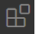. In the search bar, type “C/C++”, then click Install. Finally, restart Visual Studio Code when prompted. This extension allows us to work with C/C++ code in VS Code.

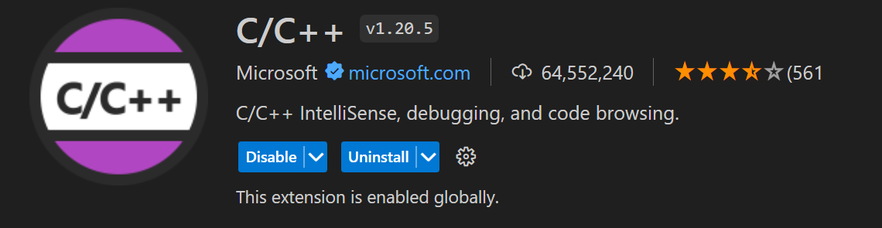

1. Install de PlatformIO extension: Launch Visual Studio Code. In the left-hand menu, click on the Extensions icon . In the search bar, type “PlatformIO IDE,” then click Install. Finally, restart Visual Studio Code when prompted.

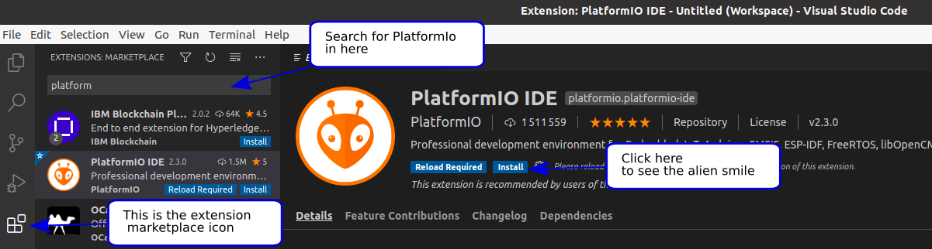

1. In Visual Studio Code, in the side menu, click on the PlatformIO icon !

If the alien icon doesn’t appear immediately, wait a few more seconds, then press F1 and type PlatformIO Home.

If this trick doesn’t work, make sure that you’ve correctly completed the VS Code setup.

1. In PlatformIO, select Clone Git Project. PlatformIO will open a field where you can paste the following URL: <https://github.com/owntech-foundation/Core> PlatformIO will ask where to clone the project. Choose the folder you previously created.

⚠ The cloned project's path must not contain spaces. If your Windows username contains spaces, try the following steps:

* Uninstall PlatformIO from VS Code
* Set a new Windows environment variable to avoid spaces by running the following command in **Command Prompt as Administrator**:

setx PLATFORMIO_CORE_DIR "C:\PlatformIO"

* Reinstall PlatformIO in VS Code.

1. Make sure you’re on the main branch of the Git project. You should see the following folder structure: Main 

Also check that you're in the PlatformIO section and that the Project Tasks have correctly updated with the folders: Owntech, Examples TWIST, and Examples SPIN.

* + 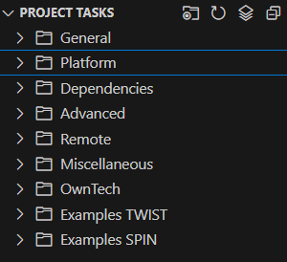In the Examples TWIST folder, you’ll find various example configurations for the power circuits.
  + In the Examples SPIN folder, you’ll find various example configurations of the main functions of the SPIN control board.

These codes can serve as a foundation for understanding the board’s main features.

## Your First Build

1. Once the OwnTech board code is installed, you can test it on the board. To do this, first make sure you are on the main branch.

Then, verify that the main.cpp file is present by going to the Source Control section.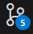.

Once you’ve located main.cpp, go to the platformio.ini file. If you can’t find this file, it is located under the src tab in the upper left.

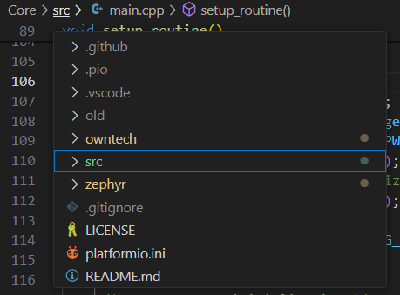

In this file, you must uncomment the following lines :  This step enables key libraries required for compiling the code.

1. In the bottom menu, click the Build icon . This will start compiling the code.
2. If this is your first time compiling, Visual Studio Code will download several necessary extensions to write the code to the OwnTech microcontroller. Once the build is complete, you should see a [SUCCESS] warning in the terminal:

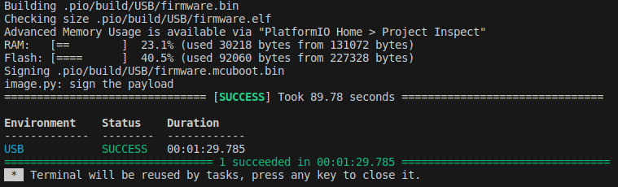

Important Notes for Windows Users:

* Make sure you are working in a folder that is **not synced with OneDrive.**
* Make sure there are **no spaces** in the path to your project.
* Make sure the total **path length** to your project is under **256 characters**. It's best to place your project folder close to the root directory.
* Make sure **Python 3** is installed on your machine.
* Make sure **CMake** is installed.
* Make sure Git is installed.

Hardware Setup

We will now connect your TWIST board to the PC. It's important to understand that there are two separate power supplies involved:

* **Control Board Power Supply**

This powers the SPIN control board, which contains the microcontroller.

To power this section, you’ll need a USB–USB-C cable (make sure it has four pins – some charging cables lack data lines).

* **Power Board Supply**

This powers the power converter section of the board.

To use this, you’ll need a **DC power supply** and a **resistor**.

For this tutorial, we’ll focus **only** on powering the control board.

1. Connect the USB-C cable to the SPIN board as shown in the image below. LED2 on the SPIN should light up.

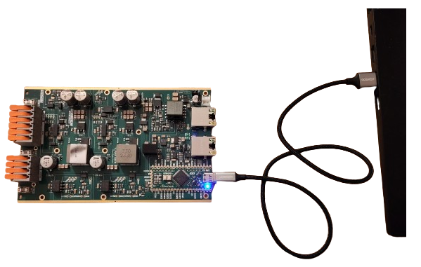

1. In the bottom menu, click the Upload icon. This will flash the compiled code to the microcontroller. Once the process is complete, you should see [SUCCESS] in the terminal.

Then, make sure you are on the correct USB port. You can verify or change this in the platformio.ini file by selecting the appropriate port if you're using the TWIST board.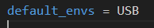

1. LED1 on the SPIN should start blinking. You can change the blink frequency by modifying the line in main.cpp: task.suspendBackgroundMs(1000)
2. In the bottom toolbar, click on the Serial Monitor icon .

The SPIN board should display: Serial Monitor.

The SPIN board displays “Hello world » in the terminal.

# Blinky: Our First Code!

## Objectives

The goal of this tutorial is to understand the code architecture in your project and use the microcontroller for the first time.

To do this, you’ll turn the onboard LED of the SPIN board on and off.

Required Hardware

* TWIST and/or SPIN

* PC 64-bits (windows or linux)

Required Software

* Git

* Visual Studio Code with PlatformIO

Understanding Your Work Environment

You’ll work in a simplified development environment, where you will interact with two main files:

* main.cpp : contains all the executable code. You will update this file throughout the tutorials.
* platformio.ini : contains the configuration for the PlatformIO project. You’ll interact with this file only occasionally.

## Modifying the Code

1. Define Variables, Functions and Drivers

At the beginning of the code, add console support:

//------------ZEPHYR DRIVERS----------------------

#include "zephyr/console/console.h"

In the USER VARIABLE DECLARATIONS section, declare a new list:

enum serial_interface_menu_mode //LIST OF POSSIBLE MODES FOR THE OWNTECH CONVERTER

{

    IDLEMODE =0,

    SERIALMODE,

} ;

uint8_t received_serial_char;

uint8_t mode = IDLEMODE;

In the LOOP FUNCTIONS DECLARATION section, add:

//--------------LOOP FUNCTIONS DECLARATION--------------------

void loop_application_task();

void loop_communication_task();

1. Configure Hardware Peripherals

In the void setup_routine() function, ensure the following:

* You are setting the correct SPIN version using setBoardVersion(SPIN_v_1_0)
* Both background tasks (communication and application) are initialized

void setup_routine()

{

    // Setup the hardware first

    data.enableTwistDefaultChannels();

    spin.version.setBoardVersion(SPIN_v_1_0);

    // Then declare tasks

    uint8_t app_task_number = task.createBackground(loop_application_task);

    uint8_t com_task_number = task.createBackground(loop_communication_task);

    // Finally, start tasks

    task.startBackground(app_task_number);

    task.startBackground(com_task_number);

}

1. Communication Task

In this loop, we implement a function that listens to characters received via the serial port. Each character switches the operating mode. Each character is associated to a different mode.

In the LOOP FUNCTION section, add:

This code listens to the serial port and makes the action associated to the received character.

void loop_communication_task()

{

    received_serial_char = console_getchar();

    switch (received_serial_char) {

        case 'h':

            //----------SERIAL INTERFACE MENU-----------------------

            printk(" ________________________________________\n");

            printk("|     ------- MENU ---------             |\n");

            printk("|     press i : idle mode                |\n");

            printk("|     press s : serial mode              |\n");

            printk("|________________________________________|\n\n");

            //------------------------------------------------------

            break;

        case 'i':

            printk("idle mode\n");

            mode = IDLEMODE;

            break;

        case 's':

            printk("serial mode\n");

            mode = SERIALMODE;

            break;

              default:

            break;

    }

}

1. Application Task

Now let’s create the application task to control LED1 based on the selected mode.

In function void loop_application_task(), add:

void loop_application_task()

{

    if(mode==IDLEMODE) {

        spin.led.turnOff();

    }else if(mode==SERIALMODE) {

        //spin.led.turnOn();

        spin.led.toggle();

    }

   task.suspendBackgroundMs(1000);

}

You can simply turn on LED1 using line **spin.led.turnOn()** or toggle LED1 using **spin.led.toggle()**

1. Connect the Hardware

(See the tutorial on environment setup.)

Connect the USB power cable. LED2 on the SPIN board should turn on.

1. Build and Upload

Click **Build**  and Upload  to compile and flash the code.

1. In the lower toolbar, click the Serial Monitor icon .

## Expected results

* Press h to display the help menu.
* Press s to switch to SERIAL mode and turn on or toggle LED1.
* Press i to switch to IDLE mode and turn off LED1.

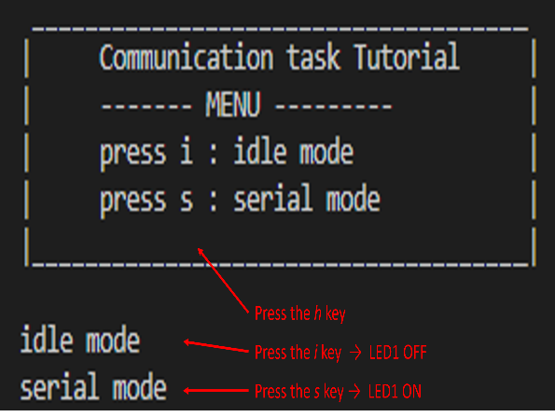

Voilà

# Saving Modifications to the Board Code using Git

## Required Software

* Git
* Visual Studio Code with PlatformIO (see first tutorial)

## Objective

Git works with a branch system. The main branch of the code is called "main". To test different operating modes of the board's converters or types of control loop (open or closed), it is necessary to modify the board's code. However, not being able to save these modifications can quickly become problematic.

## Using Git

First, we need to create a GitHub account. Then, join the GitHub group for the OwnTech tutorial by going to: [owntech-foundation/Tutorials: This folder holds the starting tutorials for the OwnTech software and hardware (github.com)](https://github.com/owntech-foundation/Tutorials) and clicking on "Follow". This will register you with their GitHub and allow you to communicate your issues.

The idea is to create new branches derived from the main branch, called "main".

To do this, click the branch button 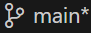 and select "Create new branch from...", then give the new branch a name (e.g., Buck).

You can verify that the new branches exist by using the command:

git branch

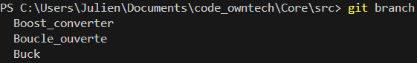

Next, we can edit the main.cpp file by switching from read mode to edit mode using the "open file" button 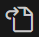.

Once the code has been modified, to save your changes, go to **Source Control** from the side menu.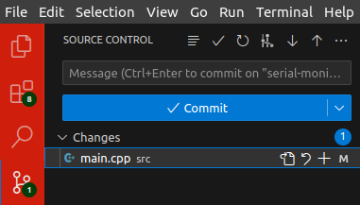

In the following example, only the main.cpp file was modified, as shown under the Changes tab. We will stage these changes to track our progress.

Click the  button on the right side of the file to *stage* the modifications.  
You can add a comment before validate your changes to know which changes were done.  
Then click the **Commit** button to save your modifications.

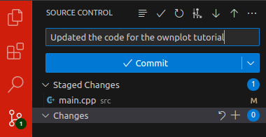

Next, make sure that the new modified branch, with the various versions, appears in “Source Control".

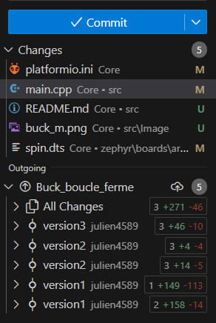

Finally, if you want to delete a branch, you can use the command:

git branch –d your_branch_name

# Buck Converter with Open-Loop

## Objective

The goal of this tutorial is to reduce the output voltage by adjusting the duty cycle. We will use our TWIST board as a step-down (buck) converter in open-loop mode to divide the input voltage by 2.

## Required Hardware

* TWIST or higher than v_1_3
* PC 64 bits (windows or linux)
* DC Power Supply (48 V, 2 A)
* Resistive Load
* Oscilloscope or Multimeter

## Required Software

* Git
* Visual Studio Code with PlatformIO (see first tutorial)

## Create the Project

1. First, we need to load the base example for the Buck voltage converter.

In PlatformIO , go to Examples Twist under the Project Tasks tab and click on “Voltage Mode Buck”.

The main.cpp file will be updated automatically. This is the file we will modify to implement an open-loop Buck converter.

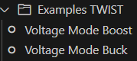.

Next, create a new branch dedicated to the Buck Open-Loop mode.

To learn how to create a new branch, refer to the tutorial "Saving Modifications to the Board Code."

## Step-by-Step Implementation

1. Define Variables

In the VARIABLE DECLARATION section, add the following variables.

* duty_cycle: stores the duty cycle of the converter. The initial duty cycle is set to 0.3.
* duty_cycle_step: defines the fixed step used to increase or decrease the duty cycle. The duty cycle step is fixed as 0.05.
* pwm_enable: it is a boolean flag indicates whether PWM is enabled or not (ON or OFF)
* control_task_period: defines the period of the control task.

//--------------USER VARIABLES DECLARATIONS----------------------

static uint32_t control_task_period = 50; //[us] period of the control task

static bool pwm_enable = false;            //[bool] state of the PWM (ctrl task)

float32_t duty_cycle = 0.2;

static float32_t duty_cycle_step = 0.05; //[-] duty cycle step (comm task)

Also add a new mode to the enum, called POWERMODE:

enum serial_interface_menu_mode //LIST OF POSSIBLE MODES FOR THE OWNTECH CONVERTER

{

    IDLEMODE =0,

    SERIALMODE,

    POWERMODE

};

1. Configure Hardware Peripherals and tasks routine

In the setup_routine() function, paste the code below.

Firstly it sets the hardware versions for the SPIN and the TWIST boards.

Then it initializes Buck mode. The TWIST converter has two legs, which can be controlled independently or interleaved. In this example, both legs are interleaved, meaning they will share the total current flowing through the power converter.

It also starts the two background tasks, communication and application tasks, and the critical task.

Further explanation about the difference between background tasks and critical tasks and their definition can be seen in the link <https://docs.owntech.org/latest/core/docs/task_introduction/>

void setup_routine()

{

    // Setup the hardware first

    spin.version.setBoardVersion(SPIN_v_1_0);

    twist.setVersion(shield_TWIST_V1_3);

    // Buck mode initialization

    twist.initAllBuck();

    data.enableTwistDefaultChannels();

    pid.init(pid_params);

    spin.pwm.setFrequency(200000); // Configure PWM frequency to 200kHz

    // Then declare tasks

    uint32_t app_task_number = task.createBackground(loop_application_task);

    uint32_t com_task_number = task.createBackground(loop_communication_task);

    task.createCritical(loop_critical_task, 100); // Uncomment if you use the critical task

    // Finally, start tasks

    task.startBackground(app_task_number);

    task.startBackground(com_task_number);

    task.startCritical(); // Uncomment if you use the critical task

}

1. Communication Task Loop

In the loop_communication_task() function, paste the following code.

This listens to the serial port and, depending on the received character, it switches between IDLEMODE, SERIALMODE, and POWERMODE.

* In IDLEMODE and SERIALMODE, PWM is disabled and there is no power conversion.
* In POWERMODE, PWM is enabled, activating power conversion.

By using cases “u” and “d”, the user can also:

* “u” -> add 0.05 to the actual duty_cycle
* “d” -> reduce 0.05 from the actual duty_cycle

void loop_communication_task()

{

    while (1)

    {

        received_serial_char = console_getchar();

        switch (received_serial_char)

        {

        case 'h':

            //----------SERIAL INTERFACE MENU-----------------------

            printk(" ________________________________________\n");

            printk("|     ---- MENU buck voltage mode ----   |\n");

            printk("|     press i : idle mode                |\n");

            printk("|     press s : serial mode              |\n");

            printk("|     press p : power mode               |\n");

            printk("|     press u : duty cycle UP            |\n");

            printk("|     press d : duty cycle DOWN          |\n");

            printk("|________________________________________|\n\n");

            //------------------------------------------------------

            break;

        case 'i':

            printk("idle mode\n");

            mode = IDLEMODE;

            break;

        case 's':

            printk("serial mode\n");

            mode = SERIALMODE;

            break;

        case 'p':

            printk("power mode\n");

            mode = POWERMODE;

            break;

        case 'u':

            printk("duty cycle UP: %f\n", duty_cycle);

            duty_cycle += duty_cycle_step;

            if(duty_cycle>1.0) duty_cycle = 1.0;

            break;

        case 'd':

            printk("duty cycle DOWN: %f\n", duty_cycle);

            duty_cycle -= duty_cycle_step;

            if(duty_cycle<0.0) duty_cycle = 0.0;

            break;

        default:

            break;

        }

    }

}

1. Application Task Loop

In the loop_application_task() function, paste the following code.

* IDLEMODE stops power conversion, data transmission and turns off LED1
* SERIALMODE enables LED1.
* POWERMODE makes LED1 blink, activates power flow, data transmission, and shows measurement values on the serial monitor.

void loop_application_task()

{

    if (mode == IDLEMODE)

    {

        spin.led.turnOff();

    }

    else if(mode==SERIALMODE)

    {

        spin.led.turnOn();

    }

    else if (mode == POWERMODE)

    {

        spin.led.toggle();

    }

    task.suspendBackgroundMs(100);

}

1. Critical Task Loop

The critical task enables/disables power conversion and sends the duty cycle to the TWIST power block. In the loop_critical_task() function, paste the following code:

It shows that if the converter is in IDLEMODE or SERIALMODE, power conversion is stopped. When POWERMODE is activated, power conversion resumes, and the duty cycle is sent to the gate drivers and the power stage.

void loop_critical_task()

{

    if (mode == IDLEMODE || mode==SERIALMODE)

    {

        if (pwm_enable == true)

        {

            twist.stopAll();

        }

        pwm_enable = false;

    }

    else if (mode == POWERMODE)

    {

        /* Set POWER ON */

        if (!pwm_enable)

        {

            pwm_enable = true;

            twist.startAll();

        }

        twist.setAllDutyCycle(duty_cycle);

    }

}

You can now save the code by staging and committing your changes.

Refer back to the tutorial “Saving Modifications to the Board Code” if needed.

1. Hardware setup

Now we will connect your TWIST board to the power supply and the PC via USB-C and do the wiring as follows:

* Connect the TWIST’s V_high and GND pins to the DC power supply (limit the supply current to 1 A).
* Connect VLow1, VLow2, and GND to a resistive load.
* Connect the USB-C port of the SPIN board to your PC.
* Turn on the power supply and set a voltage between 0 and 48 V.

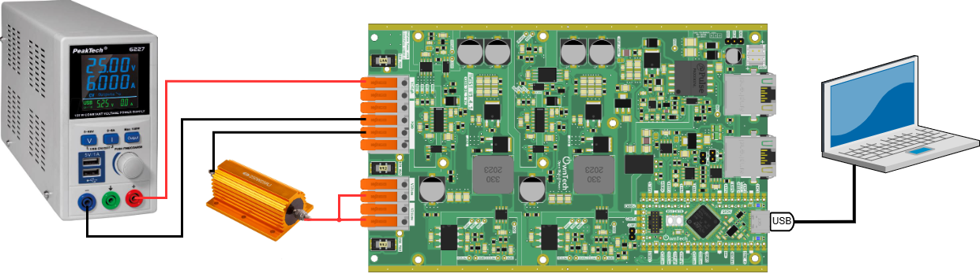

1. Build and Upload

Click Build  and Upload  to compile and flash the code.

1. Click the Serial Monitor icon  in the lower toolbar.

## Expected Results

* Press i → Enters IDLEMODE: disables power conversion, stops printing, turns off LED1
* Press s → Enters SERIALMODE: disables power conversion, prints to console, turns on LED
* Press p → Enters POWERMODE: enables power conversion, prints to console, LED1 blinks
* Press u → Increases duty_cycle
* Press d → Decreases duty_cycle

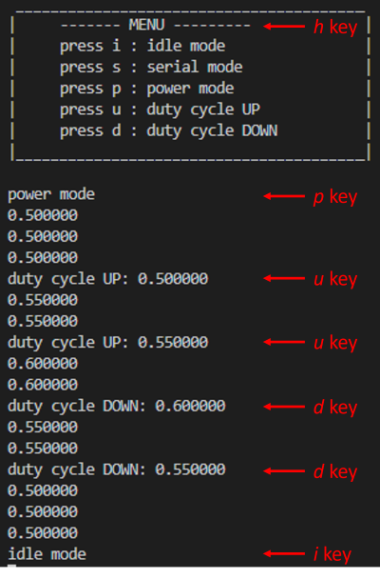

You can measure the DC output voltage using an oscilloscope or multimeter.

# Measurement Activation

## Objective

The goal of this tutorial is to activate measurements on the TWIST board, acquire them, and display the results.

We will measure the voltages 1 and 2 on the low-side ($V_{1Low}, V_{2Low}$), the currents 1 and 2 on the low-side ($I_{1Low}, I_{2Low}$), the high-side voltage ($V_{High}$), and the high-side current ($I_{High}$). These voltages and currents are marked on the circuit below.

To implement this tutorial, we’ll start from the code used in the Open-Loop Buck Converter example and extend it with measurement functionality.

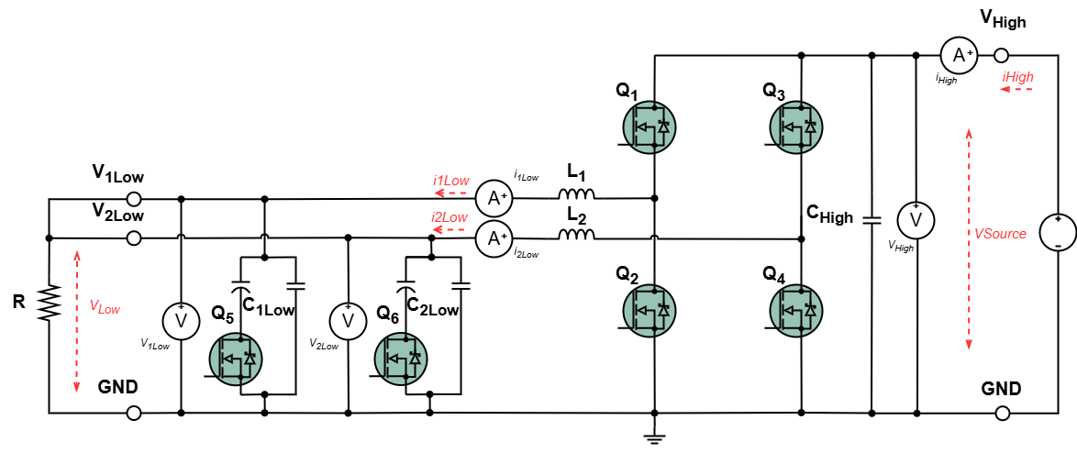

**Note**: In Buck mode, the red arrows in the diagram represent the current paths. The voltage is measured across the Low/High capacitors.

## Required hardware

* TWIST v_1_3
* 64-bit PC (Windows or Linux)
* DC Power Supply (48 V, 2 A)
* Resistive Load
* Oscilloscope or Multimeter

## Required Software

* Git
* Visual Studio Code with PlatformIO

## Creating the Project

We can reuse the branch created for the Open-Loop Buck Mode and add the measurement features to this code.

## Step-by-Step Implementation

1. Declare Variables

In the "User variable declaration" section, add the variables that will hold the measured values. Keep all the previously declared variables as well:

//--------------USER VARIABLES DECLARATIONS----------------------

/* Measure variables */

static float32_t V1_low_value;

static float32_t V2_low_value;

static float32_t I1_low_value;

static float32_t I2_low_value;

static float32_t I_high_value;

static float32_t V_high_value;

static float meas_data; // temp storage meas value (ctrl task)

1. Define the Application Task

In the loop_application_task() function, add the following code.

This displays the various measured values. **Keep the existing code as well:**

void loop_application_task()

{

printk("%f:", duty_cycle);

    printk("%f:", V_high_value);

    printk("%f:", V1_low_value);

    printk("%f:", V2_low_value);

    printk("%f:", I_high_value);

    printk("%f:", I1_low_value);

    printk("%f\n", I2_low_value);

    task.suspendBackgroundMs(100);

}

1. Define the Critical Task

In the loop_critical_task() function, add the following code. We want to retrieve all measurements by calling data.getLatest() with the appropriate identifiers:

* V_HIGH - High-side voltage
* V1_LOW - Low-side voltage 1
* V2_LOW - Low-side voltage 2
* I_HIGH - High-side current
* I1_LOW - Low-side current 1
* I2_LOW - Low-side current 2

💡 These raw values are **not calibrated** — you must calibrate the onboard sensors before relying on them for accuracy.  
Since we’re operating in **open-loop mode**, the measured values are not used to control the duty cycle, so it’s not necessary to configure feedback control in this setup

**Keep the previous code as well in the function :**

It shows that the input and output variables are updated with their instantaneous measures within the critical function only when there are measurements (power on).

void loop_critical_task()

{

    meas_data = data.getLatest(V1_LOW);

    if (meas_data != NO_VALUE)

        V1_low_value = meas_data;

    meas_data = data.getLatest(V2_LOW);

    if (meas_data != NO_VALUE)

        V2_low_value = meas_data;

    meas_data = data.getLatest(V_HIGH);

    if (meas_data != NO_VALUE)

        V_high_value = meas_data;

    meas_data = data.getLatest(I1_LOW);

    if (meas_data != NO_VALUE)

        I1_low_value = meas_data;

    meas_data = data.getLatest(I2_LOW);

    if (meas_data != NO_VALUE)

        I2_low_value = meas_data;

    meas_data = data.getLatest(I_HIGH);

    if (meas_data != NO_VALUE)

        I_high_value = meas_data;

}

You can now save your code by staging the changes and committing them (see the tutorial “Saving Modifications to the Board Code using Git”).

1. Hardware setup

Now we will connect your TWIST board to the power supply and the PC via USB-C.

* Connect the TWIST’s V_high and GND pins to the DC power supply (limit the supply current to 1 A).
* Connect VLow1, VLow2, and GND to a resistive load.
* Connect the USB-C port of the SPIN board to your PC.
* Turn on the power supply and set a voltage between 0 and 48 V.

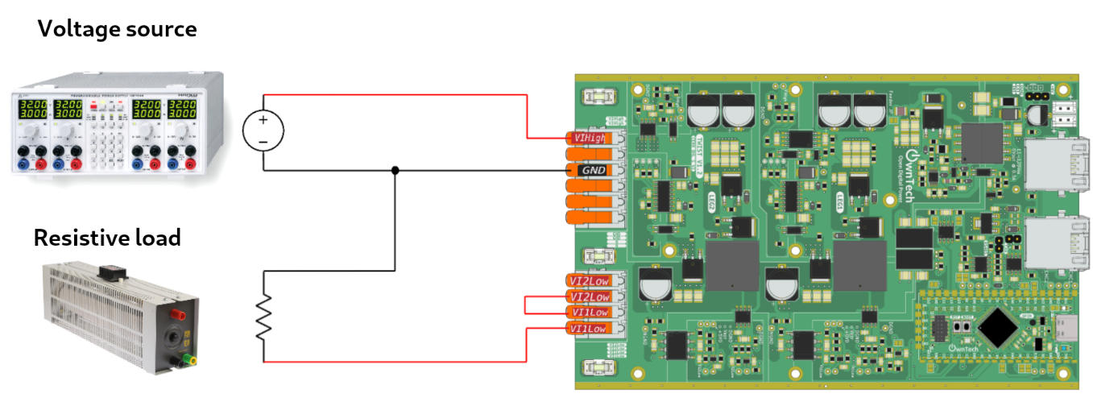

1. Build and Upload

Click Build  and Upload  to compile and flash the code.

1. Click the Serial Monitor icon  in the lower toolbar, then:

* Press p to enter POWERMODE.
* Press h to display the Human-Machine Communication Menu.

You should now see something like this:

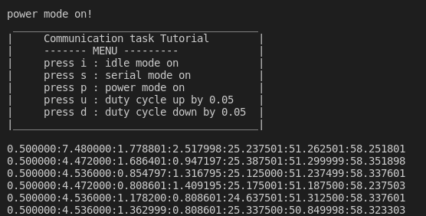

## Expected Results

* Press i → Enters IDLEMODE: disables power conversion, stops printing, turns off LED1
* Press s → Enters SERIALMODE: disables power conversion, stops printing, turns on LED
* Press p → Enters POWERMODE: enables power conversion, prints to console, LED1 blinks
* Press u → Increases duty_cycle
* Press d → Decreases duty_cycle

You can measure the DC output voltage using an oscilloscope or a multimeter. Voila !

# Board Sensors Calibration

## Required hardware

* TWIST v_1_3
* 64-bit PC (Windows or Linux)
* DC Power Supply (48 V, 2 A)
* Resistive Load
* Oscilloscope or Multimeter

## Required Software

* Git
* Visual Studio Code with PlatformIO

## Objective

Before moving on to the **closed-loop control**, it is necessary to **calibrate the board’s sensors**.  
This tutorial is the sequence of the previous tutorial: **“Measurement Activation”** and uses its code.

For initial hardware setup, connect your TWIST board to the power supply and the PC via USB-C and do the wiring as follows:

* Connect the TWIST’s V_high and GND pins to the DC power supply (limit the supply current to 1 A).
* Connect VLow1, VLow2, and GND to a resistive load.
* Connect the USB-C port of the SPIN board to your PC.
* Turn on the power supply and set a voltage between 0 and 48 V.



The variables V_HIGH and I_HIGH correspond to the **input voltage and current** of the converter.

The variables V_LOW and I_LOW correspond to the **output voltage and current** of the converter.

## What is Sensor Calibration?

Calibrating a sensor means adjusting or correcting the sensor's readings so they accurately reflect the physical quantity being measured.  
This typically involves comparing the sensor’s outputs with known reference values, and applying **correction factors** (gain and offset) to minimize measurement errors.

The correction formula is:

$$V_{real} = V_{init}⋅ gain + offset$$

These corresponds to :

* Vreal: Actual voltage/current value of the converter
* Vinit: Raw measured value from the board sensor
* gain and offset: Correction factors we want to determine to obtain accurate measurements.

The following variables will be calibrated:

* V_HIGH - High-side voltage
* V1_LOW - Low-side voltage 1
* V2_LOW - Low-side voltage 2
* I_HIGH - High-side current
* I1_LOW - Low-side current 1
* I2_LOW - Low-side current 2

Start by initializing all parameters with a gain of 1 and an offset of 0 by including the following code on the setup_rotine() function.  
This allows us to observe the raw values ($V_{init}$) as-is in the serial monitor ($V_{init} * 1 + 0 = V_{init}$).

data.setParameters(V_HIGH, 1,0);

data.setParameters(V1_LOW, 1,0);

data.setParameters(V2_LOW, 1,0);

data.setParameters(I1_LOW, 1,0);

data.setParameters(I2_LOW, 1,0);

data.setParameters(I_HIGH, 1,0);

## Calibrating V_HIGH and I_HIGH

Using a voltmeter (for V_HIGH) or an ammeter (for I_HIGH), we can measure the values on the external DC supply output.

To calibrate V_HIGH and I_HIGH, we must vary the input power supply voltage to observe how the sensor measurements of V_HIGH and I_HIGH (Vini, Iini) changes in Vscode before calibration.

⚠ Multiple measurements are printed in the serial monitor terminal. Since these measurements changes a lot, it’s recommended to use the mean value to determine Vini and Iini.

Example:

In this table, it is shown the 10 last measurements printed on the serial monitor for the test where Vmeas = 60 V for V_HIGH.



For the calibration, Vini and Ini where calculated as the mean of these last 10 sensor measured Vhigh and Ihigh, having Vini = 2005,82 V and Iini = 2258,73 A.

Then, we compare the measured values of V_HIGH and I_HIGH by the external voltmeter and ammeter (Vmeas, Imeas) with those reported by the board sensor.

An example of spreadsheet for the calibration of V_HIGH and I_HIGH sensors is:



⚠ The measured currents for Ihigh, Ilow1 and Ilow2 should be higher than 1A and lower than the maximum current 8 A for calibration.

The current sensors presents higher measurement error with currents lower than 1 A, as shown in the TWIST datasheet.

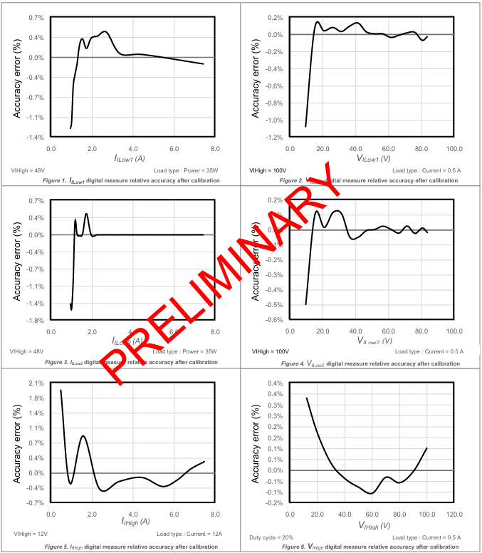

Some information about the sensors are provided in <https://docs.owntech.org/1.0.0/twist/1.4.1/getting_started/#measurement-chains>

We determine the **gain and offset** for each sensor using the spreadsheet to plot a linear regression in the format shown here form for the voltage:



$$V_{meas} = A⋅V_{init} + B$$

Where:

* Vmeas is on the **Y-axis** (measured with external equipment)
* Vinit is on the **X-axis** (raw sensor value from the board)
* A is the **gain**, and B is the **offset**

The same is done for the current:



$$I_{meas} = C⋅I_{init} + D$$

Where:

* Imeas is on the **Y-axis** (measured with external equipment)
* Iinit is on the **X-axis** (raw sensor value from the board)
* C is the **gain**, and D is the **offset**

We obtain the following curve with a **gain of 0,029826144** and an **offset of 0,149339404** for V_high and a **gain of 0,004255763** and an **offset of -8,543964735** for I_high.



The gain and the offset calculations are done using the following functions on EXCEL:

* In French:

=PENTE(Vmeas;Vini)

=ORDONNEE.ORIGINE(Vmeas;Vini

* In English :

=SLOPE(Vmeas;Vini)

=INTERCEPT(Vmeas;Vini)

Finally, we can apply the correction in Vscode for Vhigh using the gain and offset obtained from the curve.

data.setParameters(V_HIGH, 0.029826144, 0.149339404);

The same is done for the calibration values for I_high

data.setParameters(I_HIGH, 0.004255763, -8,543964735);

## Calibrating V_Low 1, 2 et I_Low 1,2 :

To perform calibrations for the low-side sensors, you need to change the hardware wirings in two times :

* For measuring V_Low1 and I_Low1:

Take out the cable connection between Low1 and Low2 pins.

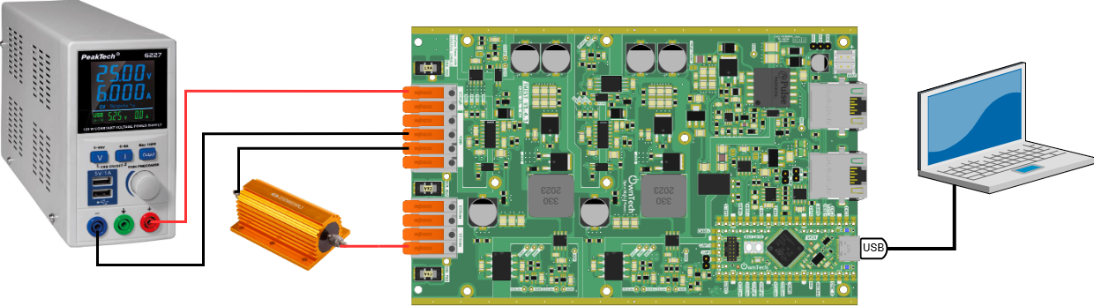

* For measuring V_Low2 and I_Low2:

Take out the cable connection between Low1 and Low2 pins and change the cable connected to the resistance to pin Low2.

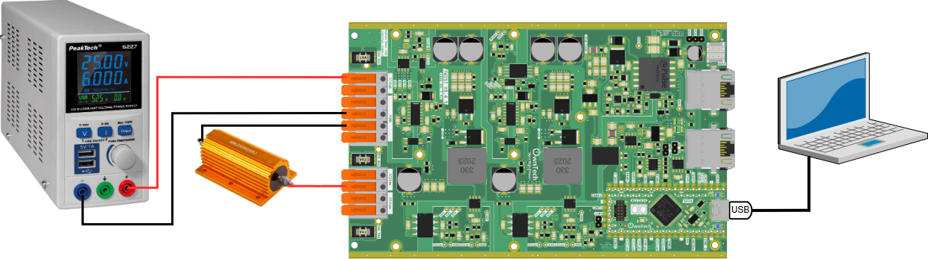

Excluding the modifications on hardware setup, the calibration is performed in the same way for both Low1 and Low2 sensors.

Using a external **voltmeter** for V_LOW or an external **ammeter** for I_LOW, we can measure its values at the resistive load output (Vmeas, Imeas).

First with the [hardware setup for calibrating Low1 sensors](../../../../../Pictures/Tutorial%20OnwTech%20TWIST-SPIN/wiring_diagram_buck_Low1calibration.png):

* With a fixed voltage on the DC power supply, we vary the **duty cycle** of the converter (using the u and d keys) to generate changes in the output voltage/current.
* Using an external **voltmeter** for V_LOW1 and an external **ammeter** for I_LOW1, we measure its values at the resistive load output (Vmeas, Imeas).
* Then, we compare the measured V_LOW1 and I_LOW1 by the external voltmeter with the raw sensor values from the board (Vini, Iini) printed in Vscode serial monitor before calibration. We note these values on the spreadsheet in order to calibrate sensors V_LOW1 and I_LOW1.

⚠ Remember that:

* It is recommended to use the mean value to determine Vini and Iini because of the high variability of the measured values printed on the serial monitor.
* The measured currents for Ihigh, Ilow1 and Ilow2 should be higher than 1A and lower than the maximum current 8 A for calibration.

Secondly using the [hardware steup for calibrating Low2 sensors](../../../../../Pictures/Tutorial%20OnwTech%20TWIST-SPIN/wiring_diagram_buck_Low2calibration.png):

* With a fixed voltage on the DC power supply, we vary the **duty cycle** of the converter (using the u and d keys) to generate changes in the output voltage/current.
* Using an external **voltmeter** for V_LOW2 and an external **ammeter** for I_LOW2, we measure its values at the resistive load output (Vmeas, Imeas).
* Then, we compare the measured V_LOW2 and I_LOW2 by the external voltmeter with the raw sensor values from the board (Vini, Iini) printed in Vscode serial monitor before calibration. We note these values on the spreadsheet in order to calibrate sensors V_LOW2 and I_LOW2.

An example of a spreadsheet for the calibration of V_LOW1, I_LOW1, V_LOW2 and I_LOW2 sensors is:



Again, using the spreadsheet we can plot a linear function in the form :

$$V_{meas} = A⋅V_{init} + B$$

$$I_{meas} = C⋅I_{init} + D$$

We obtain the following curves with:

* **gain of 0,044704488** and **offset of -90,84268992** for V_low1
* **gain of 0,00482212** and **offset of -10,07427637** for I_low1
* **gain of 0,045023763** and **offset of -91,97069779** for V_low2
* **gain of 0,004610542** and **offset of -9,478773207** for I_low2



Finally, we can apply the correction in Vscode for Vlow1 and Vlow2 using the gain and offset obtained from the curve.

data.setParameters(V1_LOW, 0.044704488,-90.84268992);

data.setParameters(V2_LOW, 0.045023763,-91.97069779);

The same is done for the calibration values for Ilow1 and Ilow2.

data.setParameters(I1_LOW, 0.00482212,-10.07427637);

data.setParameters(I2_LOW, 0.004610542,-9.478773207);

Once you’ve performed all calibrations, update the code with the complete set of correction factors:

data.setParameters(V_HIGH, 0.029826144,0.149339404);

data.setParameters(V1_LOW, 0.044704488,-90.84268992);

data.setParameters(V2_LOW, 0.045023763,-91.97069779);

data.setParameters(I1_LOW, 0.00482212,-10.07427637);

data.setParameters(I2_LOW, 0.004610542,-9.478773207);

data.setParameters(I_HIGH, 0.004255763,-8,543964735);

You can now **save your code** by staging the changes and committing them.  
Refer to the tutorial: **“Saving Modifications to the Board Code using Git”** if needed.

# Ownplot : View measured data

## Objective

This tutorial aims to teach you how to use OwnPlot, our graphical interface. It will allow you to monitor the variables of your power electronics’ device. This tutorial follows the sensor calibration and measurement activation previous tutorials.

## Required hardware

* TWIST
* PC 64 bits (windows or linux)

## Required Software

* Git
* Visual Studio Code with PlatformIO (see Blinky Tutorial)

We will use *OwnPlot* to monitor variables.

Download OwnPlot from <https://github.com/owntech-foundation/OwnPlot/releases>.  
Scroll down and you’ll find the download section. (Download version 0.6.0)

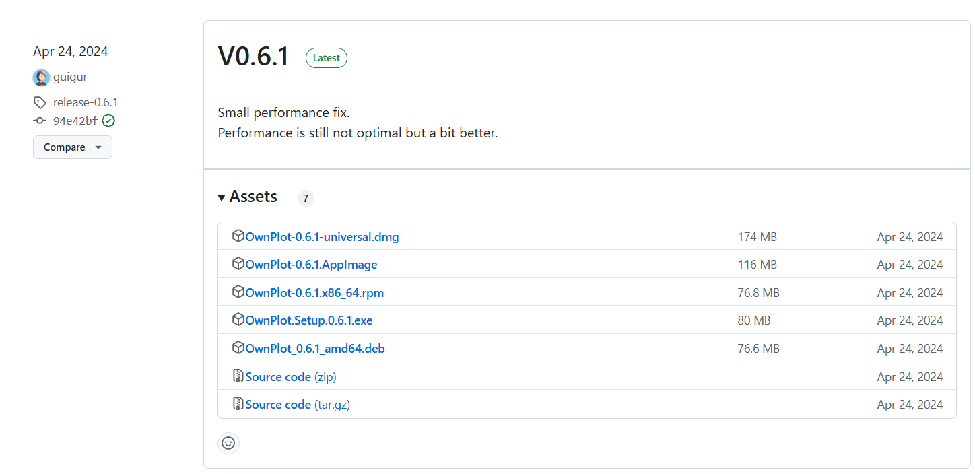

Download and install the software according to your system:



Windows

Linux

On Windows, download the .exe file and run it.

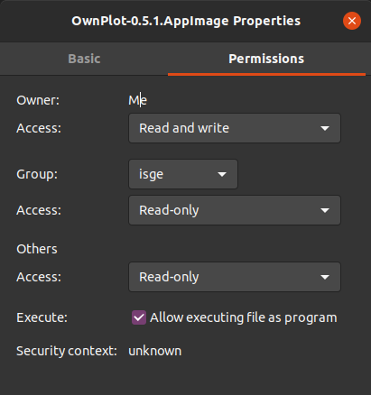

Launch *OwnPlot*. Here's what it looks like when opened.

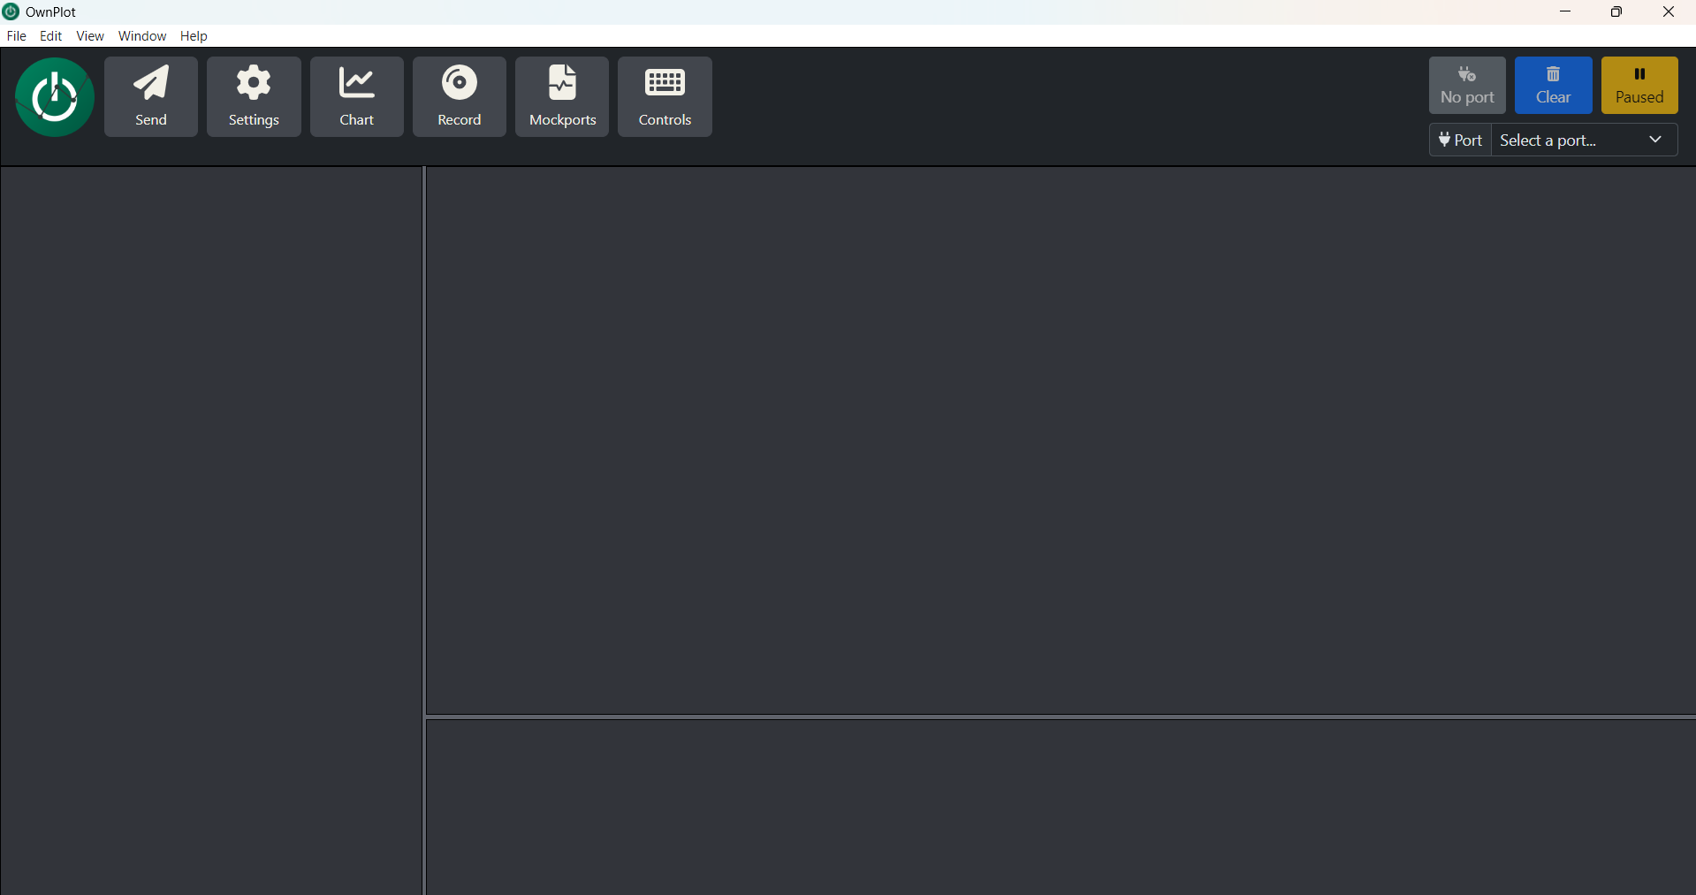

1. Hardware setup

Connect the USB-C power cable to the board. The LED2 on the SPIN should be on.



1. Build and Upload

Use the “Buck Converter with Open Loop” tutorial code with the calibration gains and offset you found in “Board Sensors Calibration” tutorial.

Click Build  and Upload  to compile and flash the code.

1. Click the Serial Monitor icon  in the lower toolbar, then:

## Expected Results

* Press i → Enters IDLEMODE: disables power conversion, stops printing, turns off LED1
* Press s → Enters SERIALMODE: disables power conversion, stops printing, turns on LED
* Press p → Enters POWERMODE: enables power conversion, prints to console, LED1 blinks
* Press u → Increases duty_cycle
* Press d → Decreases duty_cycle



## Plot with OwnPlot

We will now see the benefit of using *OwnPlot* instead of the serial monitor.

1. Check the Port Name

First, identify the name of the port connected to your PC and board.

⚠ The port name may differ depending on your operating system.  
This info appears at the start of Serial Monitor execution.

In the following example, this port is called **COM9**.

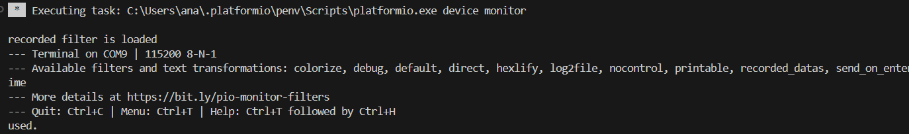

1. Close the Serial Monitor

Click on the **trash can icon** on the right side of the Serial Monitor terminal to close it, as shown below.

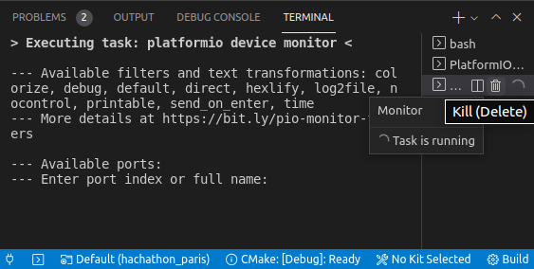

1. Launch OwnPlot

In the **Port** tab, select the port connected to your PC (e.g., if the port is COM4, select COM4.)

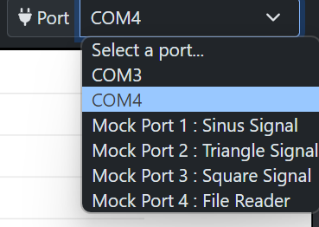

Click the **Open Port** button 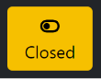 to open the port. It should change to "Open."

If you don’t find the correct port, disconnect and reconnect your device, then check again.

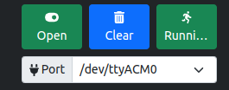

1. Set the Number of Channels

In the **Settings** tab of OwnPlot, set the number of channels you want to monitor.  
In this case, we can define **7 channels** for:  
Duty_cycle, V_high, V_Low1, V_Low2, I_Low1, I_Low2, and I_high :

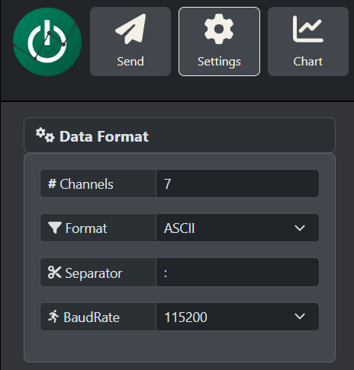

1. Customize Legends

In the **Graph** tab, scroll to *Legend* and rename the datasets.  
For example, you can rename *DATASET1* to *Duty cycle*.

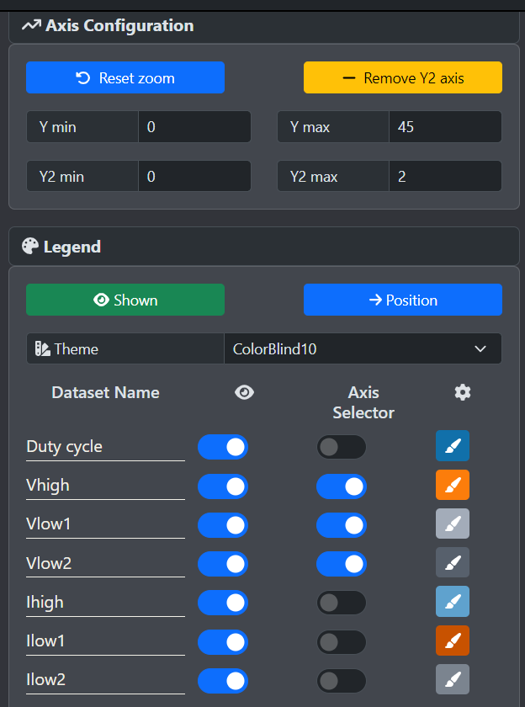

1. Configure Commands

In the **Send** tab, you can define custom commands.

* On the left, enter the command name.
* On the right, enter the corresponding key.
* Then click **Add command**.

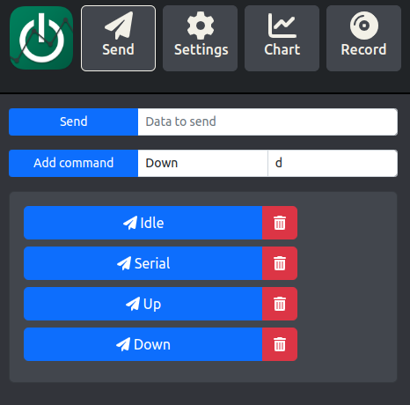

In this tutorial, we will use the preconfigured commands:

* **Idle**: Enter IDLE mode
* **Serial**: Enter SERIAL mode
* **Power**: Enter POWER mode
* **Up**: Increase duty cycle
* **Down**: Decrease duty cycle

1. Use OwnPlot Controls

Click the button associated with the **Serial** command in OwnPlot. This will activate SERIAL mode and turn on LED1.  
You should see confirmation in both LED1 and the OwnPlot interface.

You can also activate POWER mode by clicking **Power** and increase or decrease the duty cycle by clicking **Up** and **Down**.  
OwnPlot will automatically update the graph window when variable values change.

One example with only Duty cycle visible :

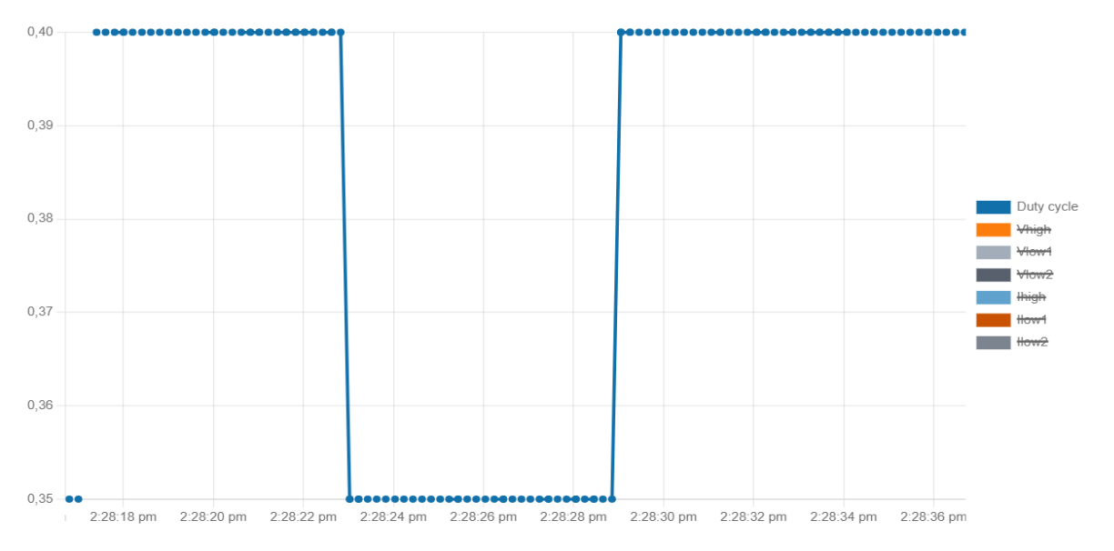

Another example with all measurements for the Buck tutorial. To do it, you can create a second Y axis clicking on **Add Y2 axis** on **Chart tab.**

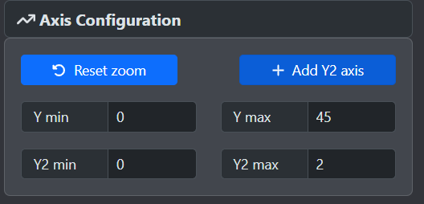

Voltage values are referred to Y1 axis and Duty cycle + current values are referred to Y2 axis.

Y2

Y1

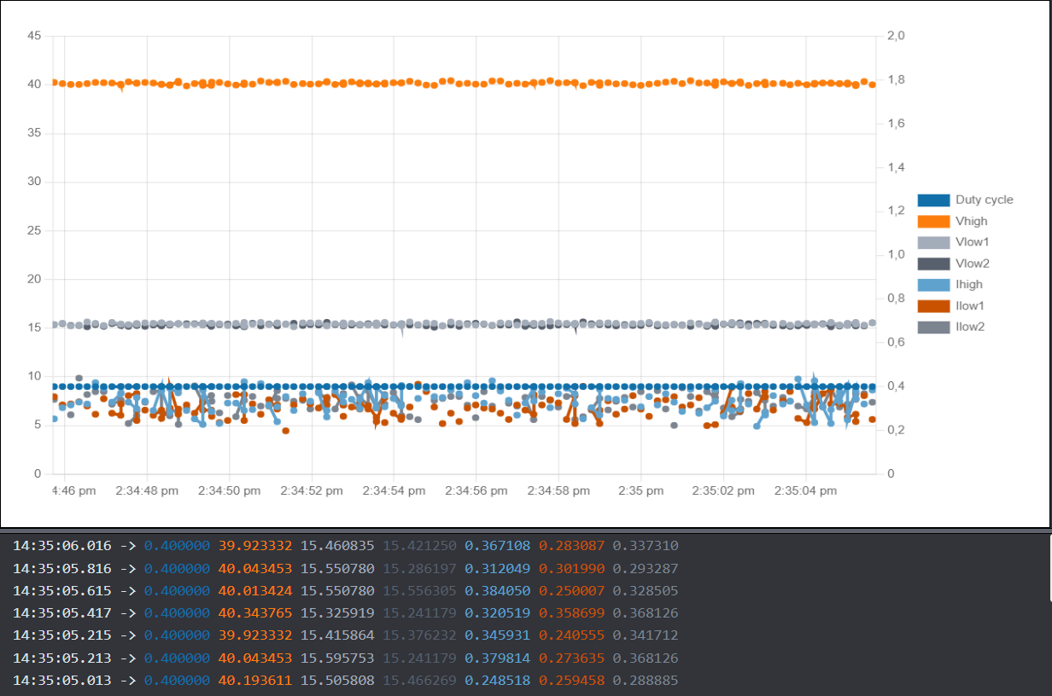

You’ve now learned how to configure data visualization using the OwnPlot graphical interface.

Voilà!

# Buck Converter in Closed Loop

The purpose of this tutorial is to use the TWIST board to step down the output voltage. This is done using a **closed-loop control**. The idea is to apply at the output of the converter a voltage set by the user, using a **PID control algorithm**.

## Required hardware

* TWIST v_1_3 or later
* 64-bit PC (Windows or Linux)
* DC Power Supply (48 V, 2 A)
* Resistive Load
* Oscilloscope or Multimeter

## Required Software

* Git
* Visual studio code

## Create the Project

1. First, we need to load the base example for the Buck voltage converter.

In PlatformIO , go to Examples Twist under the Project Tasks tab and click on “Voltage Mode Buck”.

The main.cpp file will be updated automatically. This is the file we will modify to implement an closed-loop Buck converter.

.

Next, create a new branch dedicated to the Buck Closed-Loop mode.

To learn how to create a new branch, refer to the tutorial "Saving Modifications to the Board Code."

## Step-by-Step Implementation

1. Once you’ve open the new branch, update the code with the complete set of correction factors you calculated during the “Board Sensors Calibration” tutorial in the setup_routine() function

data.setParameters(V_HIGH, 0.030031,-0.017898);

data.setParameters(V1_LOW, 0.044972283,-91.43827945);

data.setParameters(V2_LOW, 0.045018053,-91.8567704);

data.setParameters(I1_LOW, 0.004725748,-9.782756806);

data.setParameters(I2_LOW, 0.004402295,-9.021969522);

data.setParameters(I_HIGH, 0.004235355,-8.624550514);

1. Add the dutycycle to the printed data during POWERMODE in the application task function.

printk("%f:", duty_cycle);

printk("%f:", I1_low_value);

printk("%f:", V1_low_value);

printk("%f:", I2_low_value);

printk("%f:", V2_low_value);

printk("%f:", I_high);

printk("%f\n", V_high);

## Code explanation

1. Drivers

* Owntech drivers let you use the power API and all other libraries.
* Zephyr libraries uses the RTOS (real-time OS) API that we use to manage tasks on the microcontroller.

1. User Variables declaration

In this section multiple variables used during the code are declared.

* voltage_reference is the target output voltage.
* duty_cycle: stores the duty cycle of the converter. The initial duty cycle is set to 0.3.
* pwm_enable: it is a boolean flag indicates whether PWM is enabled or not (ON or OFF)
* control_task_period: defines the period of the control task.
* received_serial_char: stores the received command via serial monitor.
* meas_data: stores the last voltage and current measurements of the sensors.
* Measurement variables are used to monitor voltage and current values.
  + The suffix "high" refers to input voltage or current.
  + The suffix "low" refers to output voltage or current.
* PID related variables are also defined:

/* PID coefficient for a 8.6ms step response*/

static float32_t kp = 0.000215;

static float32_t Ti = 7.5175e-5;

static float32_t Td = 0.0;

static float32_t N = 0.0;

static float32_t upper_bound = 1.0F;

static float32_t lower_bound = 0.0F;

static float32_t Ts = control_task_period * 1e-6;

static PidParams pid_params(Ts, kp, Ti, Td, N, lower_bound, upper_bound);

static Pid pid;

* enum lists the different that can be activated by the serial monitor commands:

enum serial_interface_menu_mode // LIST OF POSSIBLE MODES FOR THE OWNTECH CONVERTER

{

    IDLEMODE = 0,

    POWERMODE

};

1. Hardware Setup Functions

In the function setup_routine(), first we setup the hardware

* spin.version.setBoardVersion(SPIN_v_1_0); configures the SPIN board version.
* twist.setVersion(shield_TWIST_V1_3); sets the TWIST board version.

Then, we set the twist operation mode (Buck, Boost or Inverter)

* twist.initAllBuck(); configures the power legs in Buck mode to step down output voltage.
* data.enableTwistDefaultChannels();
* pid.init(pid_params); initializes the pid controller with the pid_params parameters defined in the User variables declaration section.

Then we set the correction factors for the measure voltages and currents.

* data.setParameters(...) sets the gain and offset for each onboard measurement.

Then it declare and initialize the application, communication and critical tasks.

1. Loop functions and Closed-loop buck implementation

In the communication task, the SPIN listens to the serial port and, depending on the received character, it switches the converter operation between IDLEMODE, SERIALMODE, and POWERMODE.

* In IDLEMODE and SERIALMODE, PWM is disabled and there is no power conversion.
* In POWERMODE, PWM is enabled, activating power conversion.

By using cases “u” and “d”, the user can also:

* “u” -> add 0.5 to the present voltage_reference
* “d” -> reduce 0.5 from the present voltage_reference

In the critical task, the closed-loop control is implemented.

* The measurements are stored within the measurement variables defined in the User variables declaration.
* In IDLEMODE, there is no power conversion since the pwm is disabled.
* In POWERMODE, the pwm is enabled and there is power conversion. The duty cycle is computed by the PID imported from the control library, based on input (V1low) and reference voltages using the function pid.calculateWithReturn(voltage_reference, V1_low_value).
* The control task then sends the duty cycle value to all switches with twist.setAllDutyCycle(duty_cycle).

## Connect hardware and Power up

1. For initial hardware setup, connect your TWIST board to the power supply and the PC via USB-C.

* Connect Vhigh and GND of the TWIST to the DC power supply (set current limit to 1 A).
* Connect VLow1, VLow2, and GND of the TWIST to a resistive load.
* Connect the USB-C port of the SPIN to your PC via a USB cable.
* Turn on the DC power supply. Choose a voltage between 0 and 48 V.

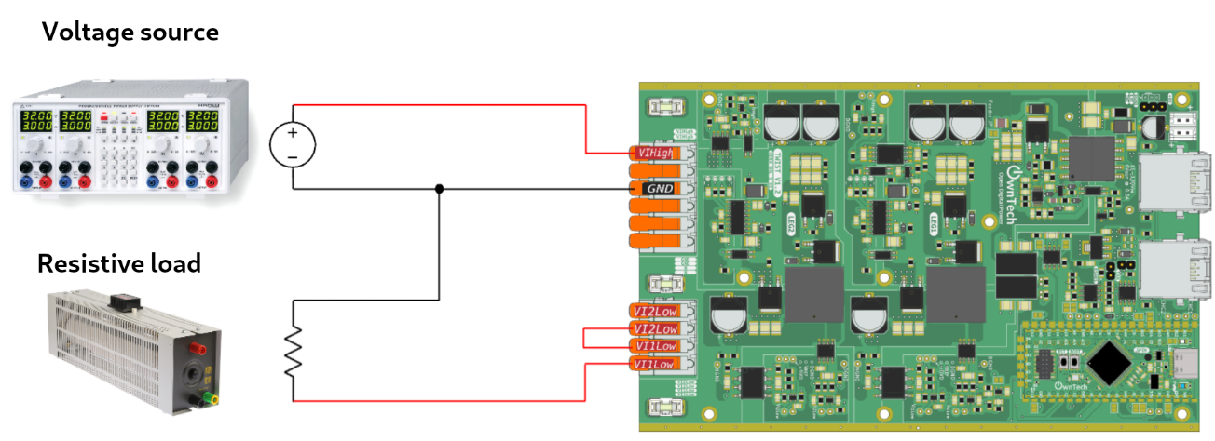

1. Build   and Upload 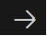
2. Use OwnPlot or the Serial Monitor to visualize your data and control the converter.

Voilà !

## Expected Results

You can try to change the DC source voltage. You will see that the duty cycle changes to keep the voltage output Vlow1 and Vlow2 in 15 V.

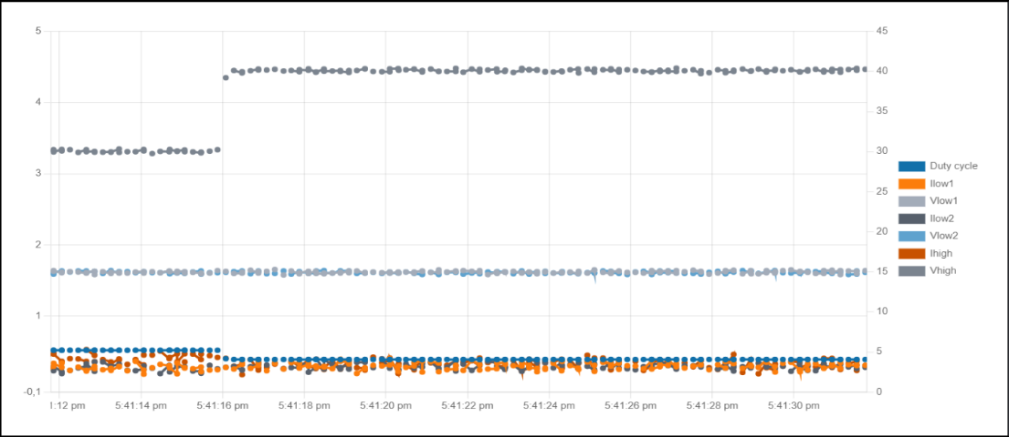

You can also try to change the voltage reference by using the commands “Up” and “Down”. You will see that the duty cycle will also increase to modify the voltage output to the new reference value.

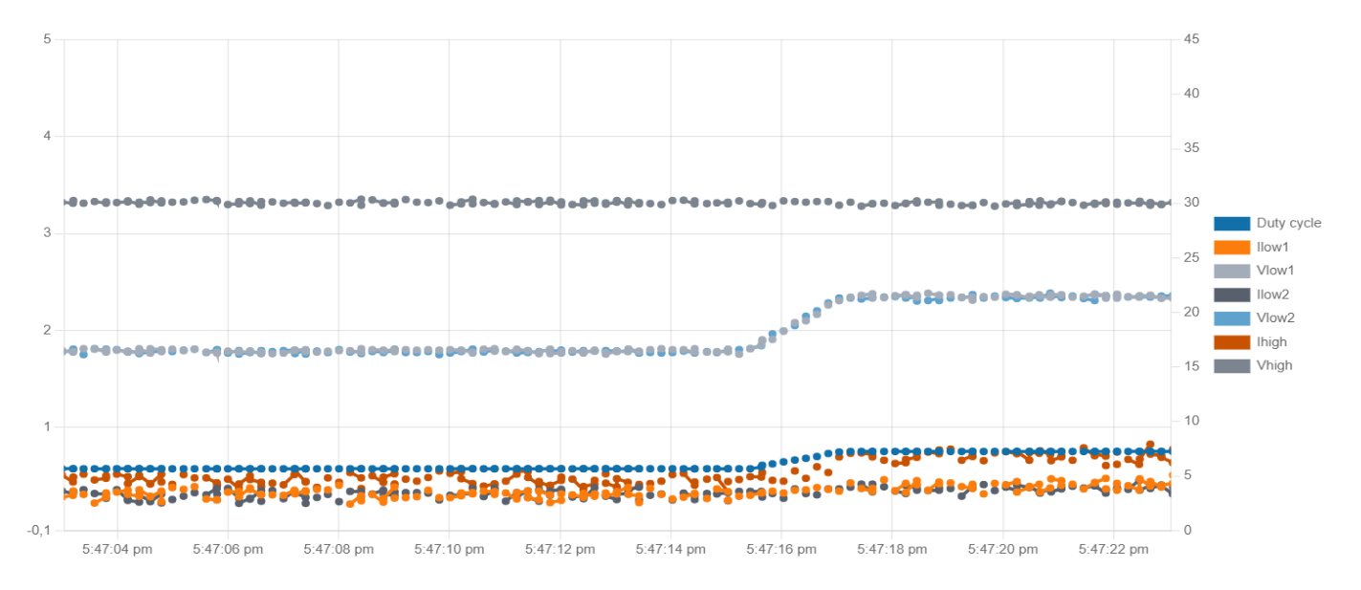

# Closed-Loop Buck Converter with Typed Adjustable Voltage Reference

Note : This program does **not** work with **OwnPlot**.

The goal of this tutorial is to use the **TWIST** board to step down the output voltage. This time, we want to be able to **manually change** the output voltage by entering it directly into the **serial monitor**.

To do this, you should **start from the previous Closed-loop Buck mode code** of the last tutorial.

## Required hardware

* TWIST v_1_3 or later
* 64-bit PC (Windows or Linux)
* DC Power Supply (48 V, 2 A)
* Resistive Load
* Oscilloscope or Multimeter

## Required Software

* Git
* Visual studio code

## Step-by-Step Implementation

1. In the OWNTECH DRIVER section, add the stdlib.h library:

//-------------OWNTECH DRIVERS-------------------

#include "stdlib.h"

1. In the void loop_communication_task() function, add the following code inside the case 'p' block to capture the value informed by the user in the serial monitor:

case 'p':

            printk("power mode\n");

            mode = POWERMODE;

{

      char input_char;

      char buffer[4];

      int index = 0;

    float new_voltage_reference = 0.0;

  printk("Voltage output is initialized at %f V\n", voltage_reference);

  printk("Enter the new voltage output (between 0 and 10 V): ");

     do {

input_char = console_getchar();

if (input_char == '\n') {

         buffer[index] = '\0';

      break;

         }

        if (input_char >= '0' && input_char <= '9' && index < 3) {

        buffer[index++] = input_char;

        }

        } while (1);

new_voltage_reference = atoi(buffer);

   if (new_voltage_reference < 0 || new_voltage_reference > 10) {

printk("Invalid input. Voltage reference must be between 0 and 10 V.\n");

    } else {

voltage_reference = new_voltage_reference;

        printk("Voltage reference set to %f V.\n", voltage_reference);

                    }

                }

            break;

case 'b':

    printk("closed-loop buck mode\n");

    mode = BUCKMODE;

    {

      char input_char;

      char buffer[4];

      int index = 0;

    float new_voltage_reference = 0.0;

  printk("Voltage output is initialized at %f V\n", voltage_reference);

  printk("Enter the new voltage output (between 0 and 10 V): ");

     do {

input_char = console_getchar();

if (input_char == '\n') {

         buffer[index] = '\0';

      break;

         }

        if (input_char >= '0' && input_char <= '9' && index < 3) {

        buffer[index++] = input_char;

        }

        } while (1);

new_voltage_reference = atoi(buffer);

   if (new_voltage_reference < 0 || new_voltage_reference > 10) {

printk("Invalid input. Voltage reference must be between 0 and 10 V.\n");

    } else {

voltage_reference = new_voltage_reference;

        printk("Voltage reference set to %f V.\n", voltage_reference);

                    }

                }

break;

## Code explanation

This code handles the "closed-loop buck mode", allowing the user to input a new voltage reference through the serial console. Here there is an detailed explanation :

Variable Initialization:

* input_char : character typed by the user.
* buffer[4] : string that stores the input digits from the user. It can stock up to 3 digits + a null character \0 to finish the string.
* index : integer variable used to track the position on the buffer string.
* new_voltage_reference : float variable initialized at 0.0 the stocks the new voltage reference converted from buffer string.

Conversion and validation :

* A do-while loop captures characters from the console until the Enter key (\n) is pressed.
* Only number digits (0–9) are stored in the buffer.
* After that the new_voltage_reference variable converts the entered string to an integer value using the function atoi.
* Into the if loop, if the entered value is between **0 and 10**, the voltage_reference becomes new_voltage_reference

## Connect Hardware and Power Up

1. For hardware setup, connect your TWIST board to the power supply and the PC via USB-C.

* Connect Vhigh and GND of the TWIST to the DC power supply (set current limit to 1 A).
* Connect VLow1, VLow2, and GND of the TWIST to a resistive load.
* Connect the USB-C port of the SPIN to your PC via a USB cable.
* Turn on the DC power supply. Choose a voltage between 0 and 48 V.



1. Build   and Upload 
2. Use a Serial Monitor (not OwnPlot) to monitor data and control your power supply.

Voilà !

# Closed-Loop Boost Converter

The goal of this tutorial is to use the TWIST board to boost the output voltage using a closed-loop control. The principle is to impose a target voltage at the output of the converter using a PID algorithm.

## Required hardware

* TWIST v_1_3 or later
* 64-bit PC (Windows or Linux)
* DC Power Supply (48 V, 2 A)
* Resistive Load
* Oscilloscope or Multimeter

## Required Software

* Git
* Visual studio code

## Create the Project

1. First, we need to load the base example for the Boost voltage converter.

In PlatformIO , go to Examples Twist under the Project Tasks tab and click on “Voltage Mode Boost”.

The main.cpp file will be updated automatically. This is the file we will modify to implement the Boost converter with closed-loop.

.

Next, create a new branch dedicated to the Boost Closed-Loop mode.

To learn how to create a new branch, refer to the tutorial "Saving Modifications to the Board Code."

## Step-by-Step Implementation

1. Once you’ve open the new branch, update the code with the complete set of correction factors you calculated during the “Board Sensors Calibration” tutorial in the setup_routine() function

/*Measurement calibration*/

data.setParameters(V_HIGH, 0.030031,-0.017898);

data.setParameters(V1_LOW, 0.044972283,-91.43827945);

data.setParameters(V2_LOW, 0.045018053,-91.8567704);

data.setParameters(I1_LOW, 0.004725748,-9.782756806);

data.setParameters(I2_LOW, 0.004402295,-9.021969522);

data.setParameters(I_HIGH, 0.004235355,-8.624550514);

1. Add the dutycycle to the printed data during POWERMODE in the application task function.

printk("%f:", duty_cycle);

printk("%f:", I1_low_value);

printk("%f:", V1_low_value);

printk("%f:", I2_low_value);

printk("%f:", V2_low_value);

printk("%f:", I_high);

printk("%f\n", V_high);

## Code explanation

1. Drivers

* Owntech drivers let you use the power API and all other libraries.
* Zephyr libraries uses the RTOS (real-time OS) API that we use to manage tasks on the microcontroller.

1. User Variables declaration

In this section multiple variables used during the code are declared.

* voltage_reference is the target output voltage.
* duty_cycle: stores the duty cycle of the converter. The initial duty cycle is set to 0.3.
* pwm_enable: it is a boolean flag indicates whether PWM is enabled or not (ON or OFF)
* control_task_period: defines the period of the control task.
* received_serial_char: stores the received command via serial monitor.
* meas_data: stores the last voltage and current measurements of the sensors.
* Measurement variables are used to monitor voltage and current values.
  + The suffix "high" refers to output voltage or current.
  + The suffix "low" refers to input voltage or current.
* PID related variables are also defined:

/* PID coefficient for a 8.6ms step response*/

static float32_t kp = 0.000215;

static float32_t Ti = 7.5175e-5;

static float32_t Td = 0.0;

static float32_t N = 0.0;

static float32_t upper_bound = 1.0F;

static float32_t lower_bound = 0.0F;

static float32_t Ts = control_task_period * 1e-6;

static PidParams pid_params(Ts, kp, Ti, Td, N, lower_bound, upper_bound);

static Pid pid;

* enum lists the different that can be activated by the serial monitor commands:

enum serial_interface_menu_mode // LIST OF POSSIBLE MODES FOR THE OWNTECH CONVERTER

{

    IDLEMODE = 0,

    POWERMODE

};

1. Hardware Setup Functions

In the function setup_routine(), first we setup the hardware

* spin.version.setBoardVersion(SPIN_v_1_0); configures the SPIN board version.
* twist.setVersion(shield_TWIST_V1_3); sets the TWIST board version.

Then, we set the twist operation mode (Buck, Boost or Inverter)

* twist.initLegBoost(LEG1); configures the power leg 1 (related to Low1 pins) in Boost mode to step up output voltage.
* data.enableTwistDefaultChannels();
* pid.init(pid_params); initializes the pid controller with the pid_params parameters defined in the User variables declaration section.

Then we set the correction factors for the measure voltages and currents.

* data.setParameters(...) sets the gain and offset for each onboard measurement.

Then it declare and initialize the application, communication and critical tasks.

1. Loop functions and Closed-loop boost implementation

In the communication task, the SPIN listens to the serial port and, depending on the received character, it switches the converter operation between IDLEMODE, SERIALMODE, and POWERMODE.

* In IDLEMODE and SERIALMODE, PWM is disabled and there is no power conversion.
* In POWERMODE, PWM is enabled, activating power conversion.

By using cases “u” and “d”, the user can also:

* “u” -> add 0.5 to the present voltage_reference
* “d” -> reduce 0.5 from the present voltage_reference

In the critical task, the closed-loop control is implemented.

* The measurements are stored within the measurement variables defined in the User variables declaration.
* In IDLEMODE, there is no power conversion since the pwm is disabled.
* In POWERMODE, the pwm is enabled and there is power conversion. The duty cycle is computed by the PID imported from the control library, based on input (Vhigh) and reference voltages using the function pid.calculateWithReturn(voltage_reference, Vhigh).
* The control task then sends the duty cycle value to all switches with twist.setAllDutyCycle(duty_cycle).

## Connect Hardware and Power Up

1. For hardware setup, connect your TWIST board to the power supply and the PC via USB-C.

* Connect VLow1 and GND of the TWIST to the DC power supply (set current limit to 1 A).
* Connect Vhigh and GND of the TWIST to a resistive load.
* Connect the USB-C port of the SPIN to your PC via a USB cable.
* Turn on the DC power supply. Choose a voltage between 0 and 48 V.

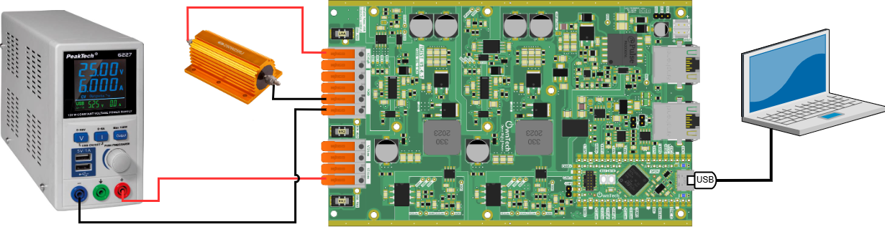

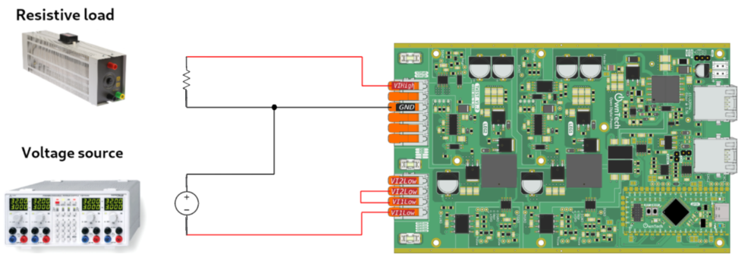

1. Build  and Upload 
2. Use OwnPlot or the Serial Monitor to visualize your data and control the converter

## Expected Results

You can try to change the DC source voltage. You will see that the duty cycle changes to keep the voltage output Vlow1 and Vlow2 in 15 V.



You can also try to change the voltage reference by using the commands “Up” and “Down”. You will see that the duty cycle will also increase to modify the voltage output to the new reference value.

# Boost Converter in Closed-Loop with Adjustable Voltage Reference

This program does not work with OwnPlot

The goal of this tutorial is to use the TWIST board to increase the output voltage. This time, we want to manually set the output voltage by entering it directly through the Serial Monitor.

To complete this tutorial, you need to start from the previous “Closed-loop Buck mode” code.

## Required hardware

* TWIST v_1_3 or later
* 64-bit PC (Windows or Linux)
* DC Power Supply (48 V, 2 A)
* Resistive Load
* Oscilloscope or Multimeter

## Required Software

* Git
* Visual studio code

## Step-by-Step Implementation

1. In the OWNTECH DRIVERS section, add the librairy « stdlib.h »:

//-------------OWNTECH DRIVERS-------------------

#include "stdlib.h"

#include "SpinAPI.h"

#include "TaskAPI.h"

#include "TwistAPI.h"

#include "DataAPI.h"

#include "opalib_control_pid.h"

//------------ZEPHYR DRIVERS----------------------

#include "zephyr/console/console.h"

1. In the void loop_application_task() function, comment out the lines corresponding to the voltage reference counter. It will no longer be needed because we are going to enter the voltage_reference value through the serial monitor.

else if(mode==BOOSTMODE) {

        spin.led.turnOn();

        //if(cpt_step==10) voltage_reference = 15;

        //if(cpt_step==20) {

        //    voltage_reference = 10;

         //   cpt_step=0;

        //}

        cpt_step ++;

    }

1. Inside case 'b':, replace the content with the following block to prompt the user for a voltage reference between 10 and 20 V:

case 'b':

    printk("closed-loop buck mode\n");

    mode = BUCKMODE;

    {

      char input_char;

      char buffer[4];

      int index = 0;

    float new_voltage_reference = 10;

  printk("Voltage output is initialized at %f V\n", voltage_reference);

  printk("Enter the new voltage output (between 10 and 20 V): ");

     do {

input_char = console_getchar();

if (input_char == '\n') {

         buffer[index] = '\0';

      break;

         }

        if (input_char >= '0' && input_char <= '9' && index < 3) {

        buffer[index++] = input_char;

        }

        } while (1);

new_voltage_reference = atoi(buffer);

   if (new_voltage_reference < 10 || new_voltage_reference > 20) {

printk("Invalid input. Voltage reference must be between 10 and 20 V.\n");

    } else {

voltage_reference = new_voltage_reference;

        printk("Voltage reference set to %f V.\n", voltage_reference);

                    }

                }

break;

## Code Explanation

This code handles the "closed-loop bost mode", allowing the user to input a new voltage reference through the serial console. Here there is an detailed explanation :

Variable Initialization:

* input_char : character typed by the user.
* buffer[4] : string that stores the input digits from the user. It can stock up to 3 digits + a null character \0 to finish the string.
* index : integer variable used to track the position on the buffer string.
* new_voltage_reference : float variable initialized at 0.0 the stocks the new voltage reference converted from buffer string.

Conversion and validation :

* A do-while loop captures characters from the console until the Enter key (\n) is pressed.
* Only number digits (0–9) are stored in the buffer.
* After that the new_voltage_reference variable converts the entered string to an integer value using the function atoi.
* Into the if loop, if the entered value is between **0 and 10**, the voltage_reference becomes new_voltage_reference

## Power Up and Connect Your TWIST Board

1. For hardware setup, connect your TWIST board to the power supply and the PC via USB-C.

* Connect VLow1, VLow2 and GND of the TWIST to the DC power supply (set current limit to 1 A).
* Connect Vhigh and GND of the TWIST to a resistive load.
* Connect the USB-C port of the SPIN to your PC via a USB cable.
* Turn on the DC power supply. Choose a voltage between 0 and 48 V.



1. Build  and Upload 
2. Use a Serial Monitor (not OwnPlot) to monitor data and control your power supply.

Voilà !

# Buck Converter: Solar Pumping with Fractional Open Circuit Voltage

## Objectif

The goal of this tutorial is to retrieve the open-circuit voltage (Voc) of a photovoltaic panel when connected to a Buck converter in open-circuit mode and, then, calculate the maximum power point voltage (Vmp) using the relation:

**Vmp = 0.78 × Voc**

Finally, we will impose this voltage at the converter input using a PID control algorithm in closed-loop Buck mode.

The PID algorithm will be used to dynamically adjust the duty cycle in order to maintain the calculated Vmp. This allows the system to adapt to changes in the input voltage and operate optimally.

The algorithm below shows that the target voltage Vmp equals 78% of the input open-circuit voltage.

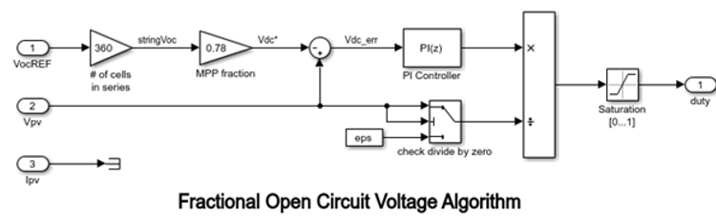

## Required hardware

* TWIST v_1_3 or later
* 64-bit PC (Windows or Linux)
* Photovoltaic panel
* Water pump (motopump)
* Oscilloscope or multimeter

## Required Software

* Git
* Visual studio code

## Step-by-Step Implementation

1. In the enum serial_interface_menu_mode, we define MPPT_A and MPPT_I modes:

enum serial_interface_menu_mode //LIST OF POSSIBLE MODES FOR THE OWNTECH CONVERTER

{

    IDLEMODE =0,

    MPPTMODE_A,

    POWERMODE,

    MPPTMODE_I,

};

Also set the control task period to 100 microseconds:

static uint32_t control_task_period = 100; //[us] period of the control task

In the *User Variable Declarations* section, initialize the variables that will be used for automatic mode switching:

//--------------USER VARIABLES DECLARATIONS----------------------

static uint32_t total_time = 0; // Elapsed time static uint32_t last_mode_change_time = 0; // Last change mode time

static const uint32_t mppt_i_duration = 100000; // Duration milliseconds (10s) static const uint32_t mppt_a_duration = 300000; // Duration milliseconds (30s)

We also initialize variables Vco and Vmp corresponding to the Open -circuit voltage and the Maximum power point voltage

static float32_t Vco;

static float32_t Vmp;

Add the MPPTMODE_A and MPPTMODE_I modes handling to the loop_communication_task:

   case 'h':

            //----------SERIAL INTERFACE MENU-----------------------

            printk(" ________________________________________\n");

            printk("|     ------- MENU ---------             |\n");

            printk("|     press i : idle mode                |\n");

            printk("|     press m : inactive mppt mode       |\n");

            printk("|     press p : power mode               |\n");

            printk("|     press u : duty cycle UP            |\n");

            printk("|     press d : duty cycle DOWN          |\n");

            printk("|     press a : active mppt mode         |\n");

            printk("|     press s : save values to file      |\n");

            printk("|________________________________________|\n\n");

            //------------------------------------------------------

            break;

case 'i':

            printk("idle mode\n");

            mode = IDLEMODE;

            break;

        case 'm':

            printk("inactive mode mppt\n");

            mode = MPPTMODE_I;

            break;

        case 'p':

            printk("power mode\n");

            mode = POWERMODE;

            break;

        case 'u':

            printk("duty cycle UP: %f\n", duty_cycle);

            duty_cycle = duty_cycle + duty_cycle_step;

            if(duty_cycle>1.0) duty_cycle = 1.0;

            break;

        case 'd':

            printk("duty cycle DOWN: %f\n", duty_cycle);

            duty_cycle = duty_cycle - duty_cycle_step;

            if(duty_cycle<0.0) duty_cycle = 0.0;

            break;

        case 'a':

            printk("active mode mppt\n");

            mode = MPPTMODE_A;

            break;

In loop_application_task we allow mode switching between MPPT_A and MPPT_I and compute Vco and Vmp:

        if (mode == MPPTMODE_I && (total_time - last_mode_change_time) >= mppt_i_duration) {

         mode = MPPTMODE_A;

printk("MPPT mode actif\n");

         last_mode_change_time = total_time;

        } else if (mode == MPPTMODE_A && (total_time - last_mode_change_time) >= mppt_a_duration) {

            mode = MPPTMODE_I;

            printk("MPPT mode inactif\n");

            last_mode_change_time = total_time;

        }

    if(mode==IDLEMODE) {

        Vco=V_high_value;

        spin.led.turnOff();

    }else if(mode==MPPTMODE_I) {

        Vco=V_high_value;

        spin.led.turnOff();

    }else if(mode==POWERMODE) {

        spin.led.toggle();

    }else if(mode==MPPTMODE_A) {

        spin.led.turnOn();

        cpt_step ++;

    }

    printk("%f:", Vco);

    printk("%f\n", Vmp);

    Vmp= 0.78*Vco;

}

In loop_control_task function, we assign the elapsed time since the beginning of the program to variable total_time. Finally, we enforce Vmp by changing the duty cycle with a PID controller.

void loop_control_task()

{

static uint32_t tick_count = 0;

    tick_count++;

    // Increment elapsed time every 100 microsecond (assuming loop_control_task runs every 100 microsecond)

    if (tick_count >= control_task_period) {

        total_time += tick_count;

        tick_count = 0;

    }

if(mode==IDLEMODE || mode==MPPTMODE_I) {

         pwm_enable = false;

         twist.stopAll();

    }else if(mode==POWERMODE || mode==MPPTMODE_A) {

        if(!pwm_enable) {

            pwm_enable = true;

            twist.startAll();

        }

  if(mode==MPPTMODE_A){

  duty_cycle = opalib_control_interleaved_pid_calculation(Vmp, V_high_value);

    }

    //Sends the PWM to the switches

    twist.setAllDutyCycle(duty_cycle);

    }

}

## Code explanation

1. Voc Retrieval: We retrieve the open-circuit voltage (Voc) from the photovoltaic panel by reading V_high when the converter is in MPPTMODE_I (mppt inactive), i.e., when the output behaves as an open-circuit.
2. Vmp Calculation: We compute the maximum power voltage (Vmp) using the formula Vmp = 0.78 × Voc.
3. PID Algorithm: The PID controller dynamically adjusts the duty cycle to maintain Vmp at the buck converter input according to the difference between the real measured voltage and the desired voltage (Vmp). The PID algorithm is only active in MPPTMODE_A (mppt active).
4. The code switches automatically between active and inactive MPPT modes:

* 30 seconds in active MPPT mode
* 10 seconds in inactive MPPT mode

This allows the system to frequently update the Voc value, which varies throughout

the day due to changing irradiance and solar panel position.

## Connect Hardware

1. For hardware setup, connect your TWIST board to the power supply and the PC via USB-C.

* Connect Vhigh and GND of the TWIST to the photovoltaic panel (set a 2 A current limit).
* Connect VLow1, VLow2, and GND of the TWIST to a motor pump.
* Connect the USB-C port of the SPIN to your PC via a USB cable.

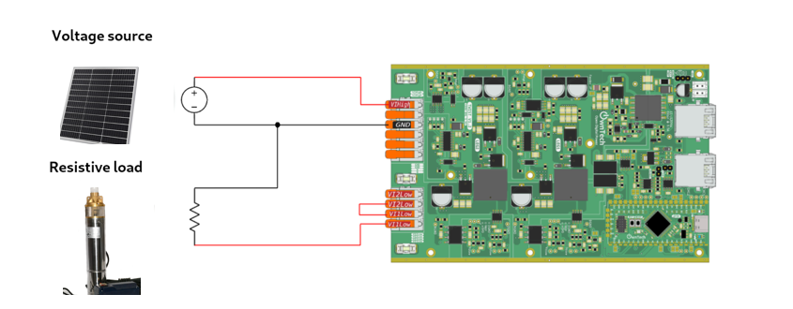

1. Build   and Upload 
2. Use OwnPlot or the Serial Monitor to visualize your data and control the converter.

Voilà !

# Buck Converter MPPT : Constant-Step Perturb and Observe

## Tutorial Objective

The goal of this tutorial is to implement a Perturb and Observe (P&O) algorithm for MPPT. This algorithm is designed to track and maintain the optimal operating point of a photovoltaic (PV) panel based on the connected load, such as a pump. By periodically perturbing the duty cycle and observing the resulting power changes, the algorithm adjusts the operating point to maximize the solar system’s energy efficiency, even in the presence of variations in irradiance, temperature, and load demand.

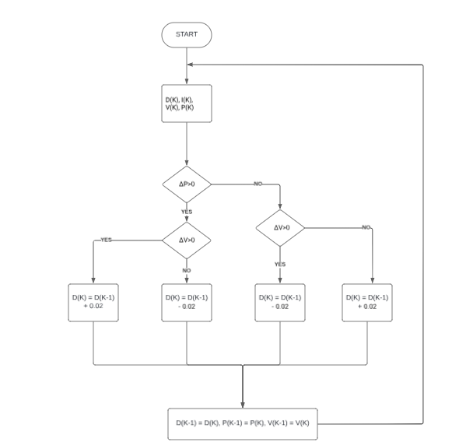

## Step-by-Step Implementation

In the user variable declaration section, we initialize the following variables:

//--------------USER VARIABLES DECLARATIONS-------------------

#define BUFFER_SIZE 20

static float32_t bufferI[BUFFER_SIZE];

static float32_t Ifinal;

static float32_t bufferV[BUFFER_SIZE];

static float32_t Vfinal=0;

static float32_t Vprev=0;

static int secuV = 0;

static int bufferp;

static float32_t Pfinal =0;

static float32_t Pprev =0;

static float32_t deltaP;

static float32_t deltaV;

We define two operating modes in the enum serial_interface_menu_mode: IDLEMODE and POWERMODE. Then, we initialize the converter legs in buck mode.

enum serial_interface_menu_mode // LIST OF POSSIBLE MODES FOR THE OWNTECH CONVERTER

{

    IDLEMODE = 0,

    POWERMODE

};

uint8_t mode = IDLEMODE;

/* buck voltage mode */

    twist.initAllBuck();

In void loop_application_task(), we implement a protection mechanism to prevent overvoltage on the converter output. The pump's nominal voltage is 24 V, so we set an upper limit of 23.9 V. The output voltage must also be no less than 3.1 V.

 case 'u':

            if (V1_low_value >= 23.9)  //security for not overvoltage

            {

                duty_cycle -= 0.02;

                printk("La tension est déjà au maximum\n");

                printk("tension cible : %f\n\n", voltage_reference);

            }

            else

            {

              printk("duty cycle UP: %f\n", duty_cycle);

              duty_cycle = duty_cycle + duty_cycle_step;

              if(duty_cycle>0.9) duty_cycle = 0.9;

            }

            break;

        case 'd':

            if (V1_low_value <= 3.1)   //security for not undervoltage

                {

                  duty_cycle += 0.02;

                  printk("La tension est déjà au minimum\n");

                  printk("tension cible : %f\n\n", voltage_reference);

               }

               else

                {

                  printk("duty cycle DOWN: %f\n", duty_cycle);

                  duty_cycle = duty_cycle - duty_cycle_step;

                  if(duty_cycle<0.1) duty_cycle = 0.1;

                }

            break;

Add the following code in void loop_application_task() to implement the P&O MPPT algorithm. It adjusts the converter’s duty cycle based on power and voltage variations to maximize PV system efficiency.

bufferI[bufferp] = I1_low_value;

bufferV[bufferp] = (V1_low_value <= 0) ? 0 : V1_low_value;

bufferp += 1;

if (bufferp == BUFFER_SIZE)

{

   bufferp = 0;

    secuV = 0;

    for (int bufferp = 0; bufferp < BUFFER_SIZE; bufferp++) {

    Ifinal += bufferI[bufferp];

    Vfinal += bufferV[bufferp];

    if (bufferV[bufferp] == 0) {

        secuV++;

    }

}

    Ifinal = Ifinal / BUFFER_SIZE;

    Vfinal = Vfinal / BUFFER_SIZE;

    Pfinal = Ifinal * Vfinal;

    deltaP = Pfinal - Pprev;

    deltaV = Vfinal - Vprev;

    if(secuV >= 5)     // Si trop d'activité, évite comparaison et reporte au buffer suivant

    {

        printk("Alimentation trop peu stable / trop basse\n");

    }

  else if (deltaP >= 0  )

    {

      if (V1_low_value >= 23.9)      // Sécurité pour éviter la surtension

        {

            duty_cycle = duty_cycle_prev – 0.02;

            if(duty_cycle<0.15) duty_cycle = 0.15;

            printk("La tension est déjà au maximum\n");

            printk("La rapport cyclique passe à : %f\n",duty_cycle);

        }

      else if (deltaV> 0)

        {

            duty_cycle = duty_cycle_prev + 0.02;

            if(duty_cycle>0.85) duty_cycle = 0.85;

            printk("Le rapport cyclique a augmenté de %f \n", deltaD);

        }

        else

        {

            duty_cycle = duty_cycle_prev – 0.02 ;

            if(duty_cycle<0.15) duty_cycle = 0.15;

            printk("Le rapport cyclique a diminué de %f \n", deltaD);

         }

     }

    else if(deltaP < 0)

     {

        if (V1_low_value <= 3.1)       // Sécurité pour éviter la sous-tension

        {

            duty_cycle =  duty_cycle_prev + 0.02;

            if(duty_cycle>0.85) duty_cycle = 0.85;

            printk("La tension est déjà au minimum\n");

            printk("La rapport cyclique passe à : %f\n",duty_cycle);

        }

         else if (deltaV > 0)

        {

           duty_cycle  = duty_cycle_prev – 0.02 ;

            if(duty_cycle>0.85) duty_cycle = 0.85;

            printk("Le rapport cyclique a diminué de %f \n", deltaD);

        }

        else {

            duty_cycle = duty_cycle_prev + 0.02 ;

            if(duty_cycle<0.15) duty_cycle = 0.15;

            printk("Le rapport cyclique a augmenté de %f \n", deltaD);

        }

      }

    printk("Is : %fA   ||   Vs : %fV   ||   Ve : %fV   ||   α : %f\n", I1_low_value, V1_low_value, V_high, duty_cycle);

    printk("Tension cible : %fV  ||  Pfinal : %fW\n", voltage_reference, Pfinal);

    printk("Vprev : %fV  ||  deltaP : %fW  ||  deltaV : %f\n", Pprev, deltaP, deltaV);

    Pprev = Pfinal;

    duty_cycle_prev = duty_cycle;

    Vprev = Vfinal;

    printk("===============================================================================\n\n");

  }

}

In function void loop critical task (), add this code to control the pwm activation:

 if (mode == IDLEMODE)

    {

        if (pwm_enable == true)

        {

            twist.stopAll();

        }

        pwm_enable = false;

    }

    else if (mode == POWERMODE)

    {

        if(!pwm_enable) {

            pwm_enable = true;

            twist.startAll();

        }

        //Sends the PWM to the switches

    twist.setAllDutyCycle(duty_cycle);

    }

}

## Code explanation

* bufferI and bufferV: Arrays that store current and voltage readings over a time window defined by BUFFER_SIZE.
* bufferp: Index used to fill bufferI and bufferV arrays, incremented after each sample.
* I1_low_value and V1_low_value: Measured output current and voltage.
* If V1_low_value <= 0, we clamp it to 0 to avoid negative or invalid values.
* When bufferp reaches BUFFER_SIZE, this means that the buffer is complete and ready to be treated. It is reinitialized at 0 and starts to stock new values. secuV is also reinitialized at 0.

A loop iterates through the buffers to calculate the sum of the current values (stored in Ifinal) and the voltage values (stored in Vfinal). During this process, if any voltage value in the buffer is equal to zero, the secuV counter is incremented in order to keep track of the number of zeros.

Once the loop has processed all values, the accumulated sums for current and voltage are divided by the constant BUFFER_SIZE in order to compute the average current and average voltage over the buffer period. Also:

* Pfinal is calculated as the product of the average current (Ifinal) and the average voltage (Vfinal).
* deltaP is computed as the difference between the current power value (Pfinal) and the previous iteration’s power value (Pprev).
* deltaV is calculated as the difference between the current average voltage (Vfinal) and the voltage value from the previous iteration (Vprev).
* If the secuV counter is greater than or equal to 5—meaning that at least five zero voltage readings were encountered in the buffer—a warning message is printed to indicate that the input voltage is too unstable or too low, and the MPPT comparison and duty cycle adjustment are skipped for this iteration.

If deltaP is positive or zero (indicating that the power has increased or remained constant since the last iteration), the algorithm then checks the current output voltage:

* If the voltage is greater than or equal to 23.9 V (the upper safety threshold), the duty cycle is decreased to prevent overvoltage.
* If the voltage is below 23.9 V and deltaV is positive (i.e., the voltage has increased since the last iteration), the duty cycle is increased to try to reach a higher power point.
* If the voltage is below 23.9 V but deltaV is negative (i.e., voltage has decreased), the duty cycle is decreased to search in the opposite direction on the power curve.

On the other hand, if deltaP is negative (indicating a drop in power compared to the previous iteration):

* If the output voltage is less than or equal to 3.1 V (the lower safety limit), the duty cycle is increased to avoid undervoltage and ensure the load continues to operate.
* If the voltage is above 3.1 V and deltaV is positive (voltage increased), the duty cycle is decreased to move away from a less efficient operating point.
* If the voltage is above 3.1 V and deltaV is negative (voltage decreased), the duty cycle is increased to explore a potentially better operating point.

At each iteration, the current values of the measured current, voltage, calculated power, and duty cycle are printed to the serial interface for monitoring and debugging. Additionally, the current values of power (Pfinal), duty cycle (duty_cycle), and voltage (Vfinal) are stored so they can be used in the next iteration to compute the new deltaP and deltaV. This allows the Perturb and Observe algorithm to dynamically adjust the converter operation to maximize power extraction from the photovoltaic source.

## Connect Hardware

1. For hardware setup, connect your TWIST board to the power supply and the PC via USB-C.

* Connect Vhigh and GND of the TWIST to the photovoltaic panel (set a 2 A current limit).
* Connect VLow1, VLow2, and GND of the TWIST to a motor pump.
* Connect the USB-C port of the SPIN to your PC via a USB cable.



1. Build   and Upload 
2. Use OwnPlot or the Serial Monitor to visualize your data and control the converter.

Voilà !

